**INDEX**

|  |  |
| --- | --- |
| **Sr. No** | **Practical** |
| 1 | Install, configure and run Hadoop and HDFS ad explore HDFS. |
| 2 | Implement word count / frequency programs using MapReduce |
| 3 | Implement an MapReduce program that processes a weather dataset. |
| 4 | Implement the program using Pig. |
| 5 | Implement the application in Hive. |
| 6 | Implement an application that stores big data in Hbase/ Python |
| 7 | Implement Decision tree classification techniques |
| 8 | Implement SVM classification techniques |

**Practical 1**

|  |
| --- |
| Install, configure and run Hadoop and HDFS ad explore HDFS. |

Download Virtual machine setup ie VMware setup (in which Hadoop is configured.Step 1: Load the server on VM ware workstation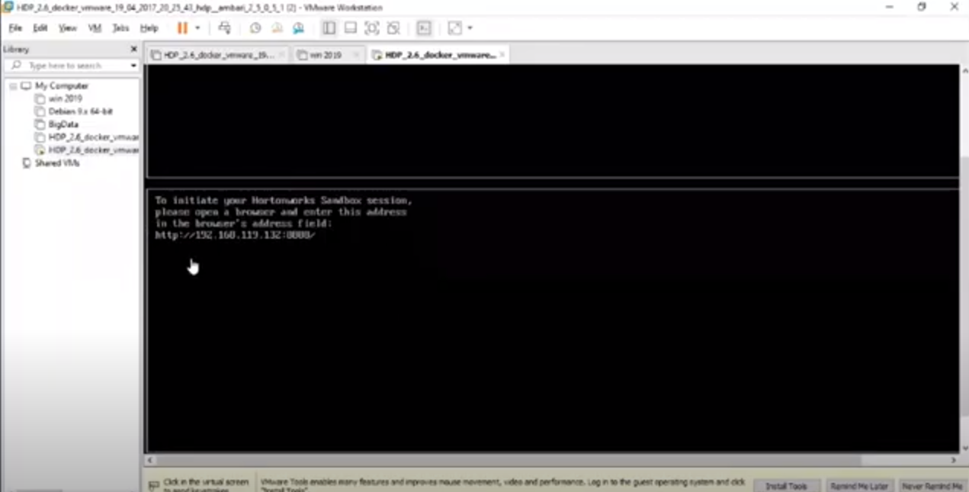

Step 2: To enable admin login open shell and reset root login.

Open Terminal 192.168.119.132:4200

In Sandbox login enter root

And Password is Hadoop

And reset the password

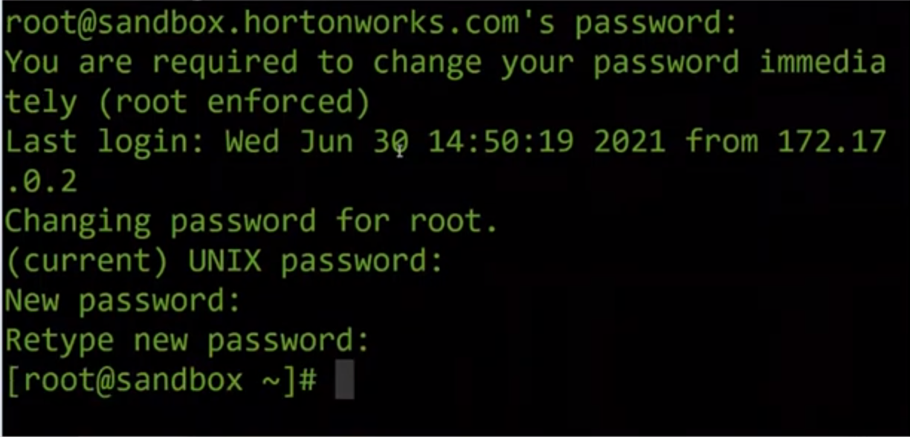

Windows linux system and Hadoop system are different

When we type **ls** command it is executed in local system

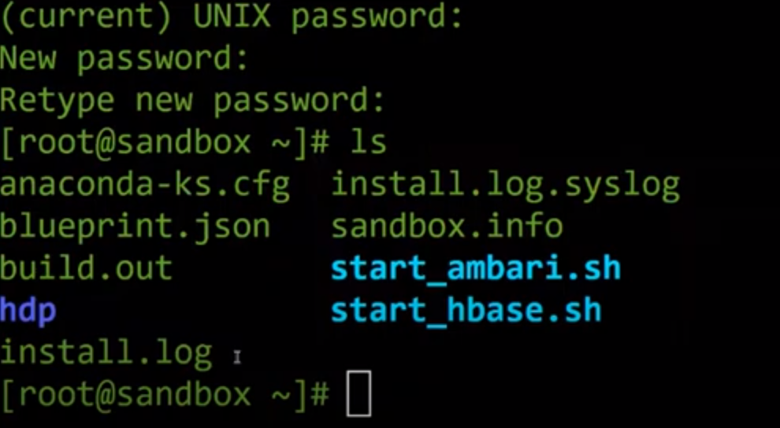

When we type **hdfs dfs -ls** it will execute in Hadoop system directory

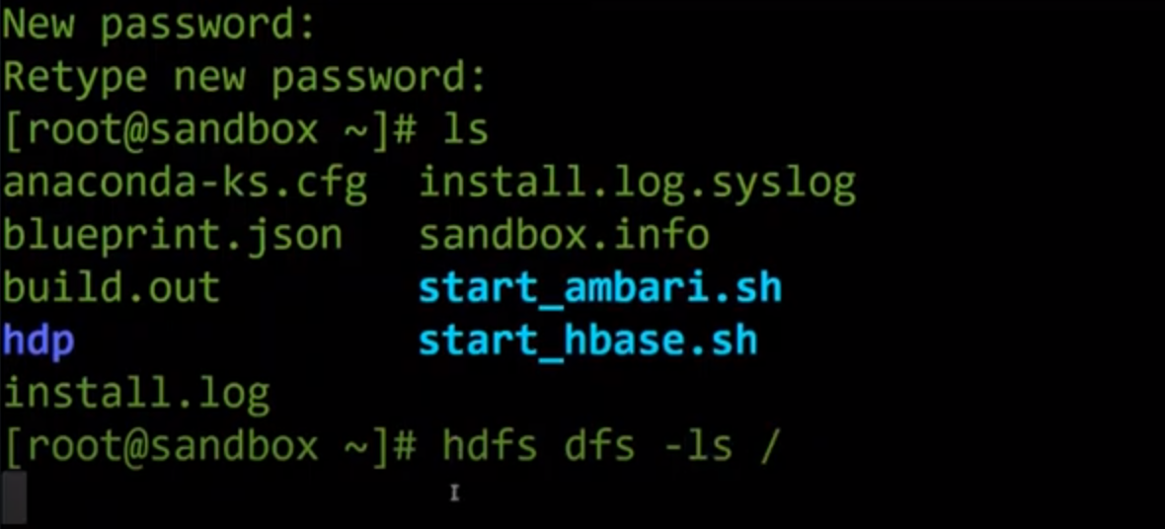

Step 3: Reset Admin account Password

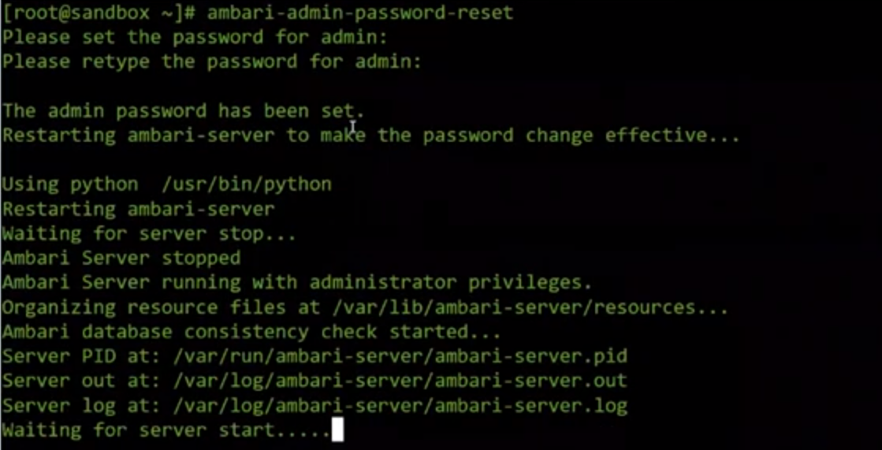

Server listening on 8080 and shell login is complete.

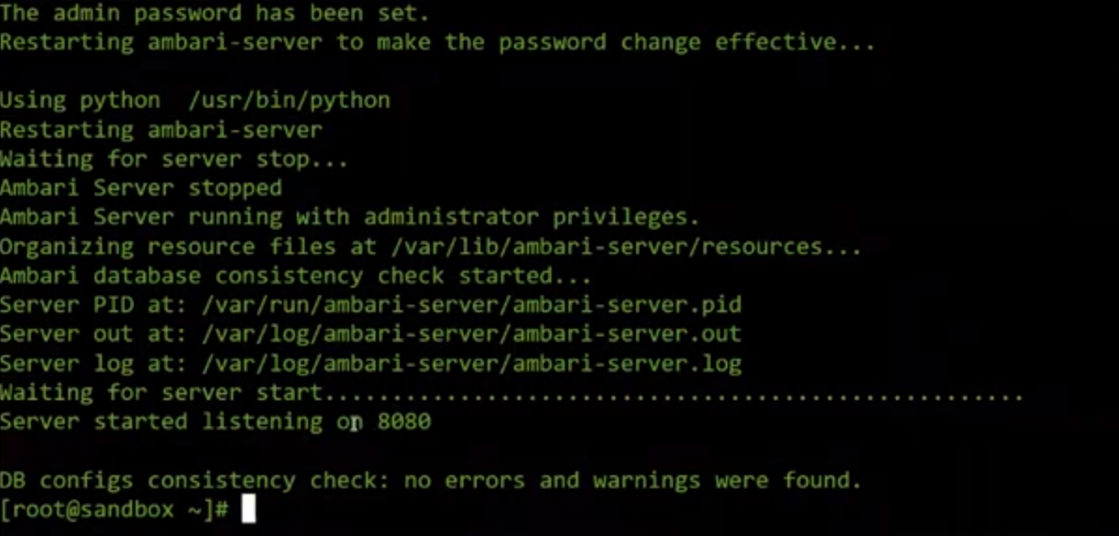

To use graphical user interface login to 192.168.119.132:4200



Click on Launch DashboardEnter the username and password for admin login.

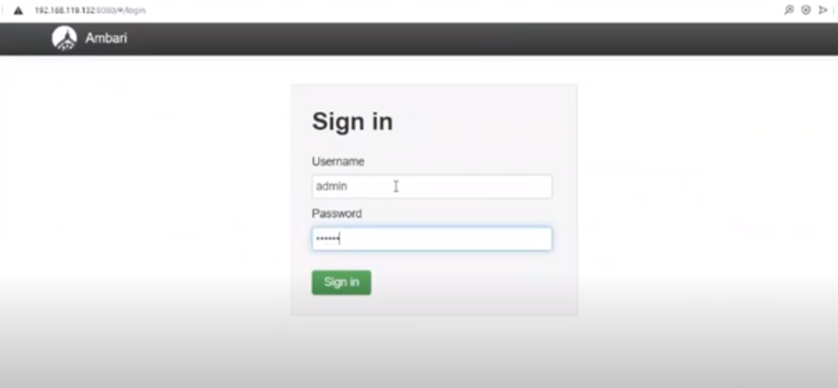

Below is the Hadoop server.

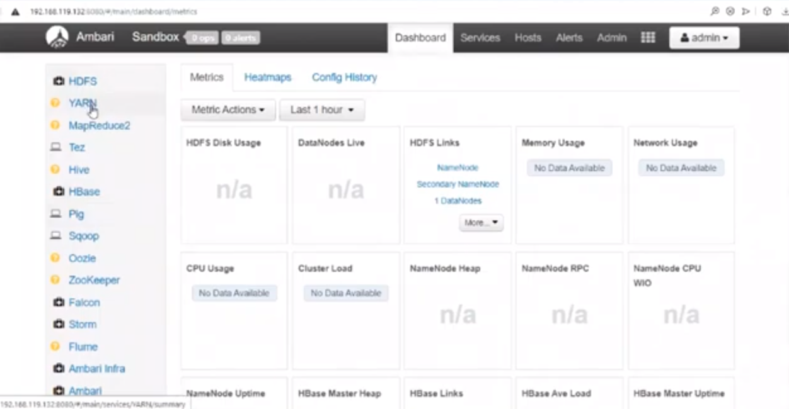

To view file in HDFS click on HDFS and click on File view.

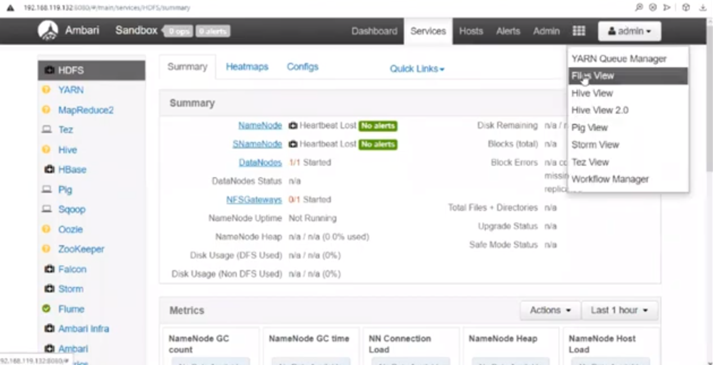Commands:

1. To view root folder file from terminal use command hdfs dfs -ls /user and press enter.

It will display all the files in the root user that we see in UI(Screenshot 2).

**ls:** This command is used to list all the files

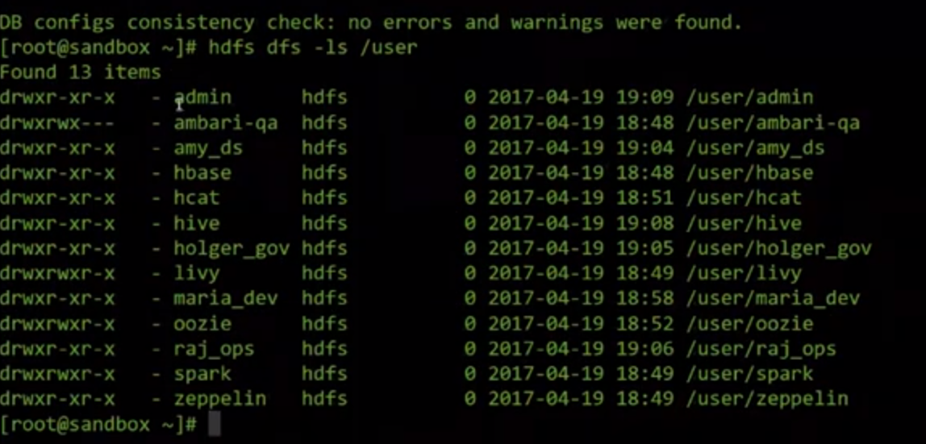

1. 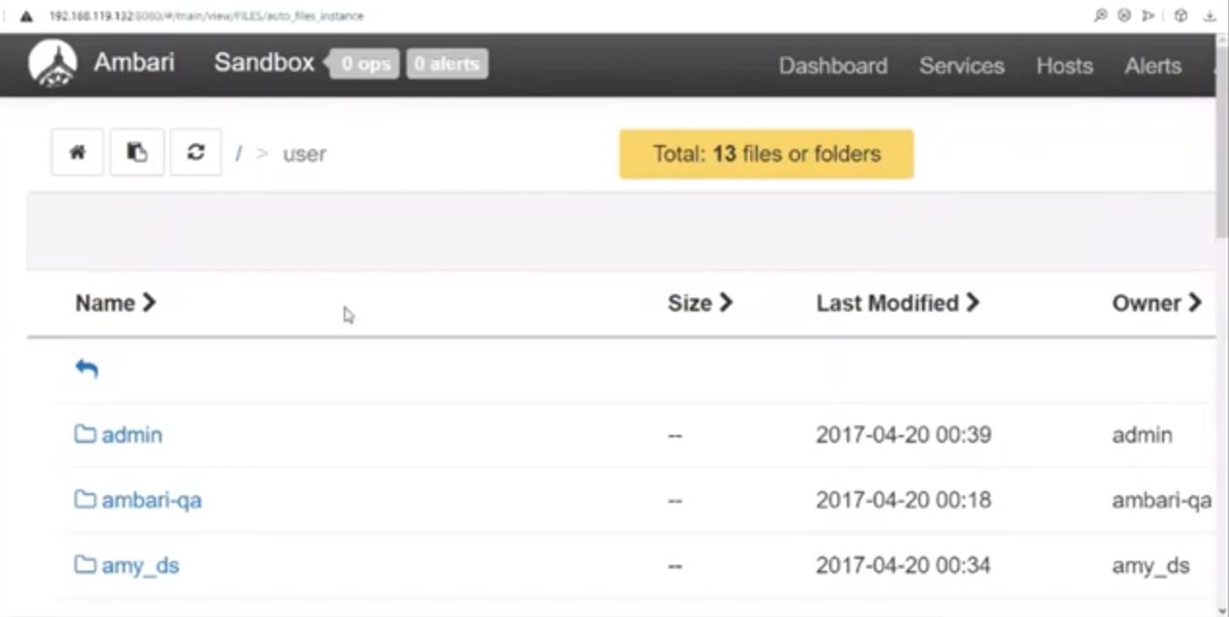**mkdir**: To create a directory.

Create a folder in Hadoop directory. Type command hdfs dfs -mkdir /bigdatatest and enter. After it execute the command, we will see whether it is created folder in UI.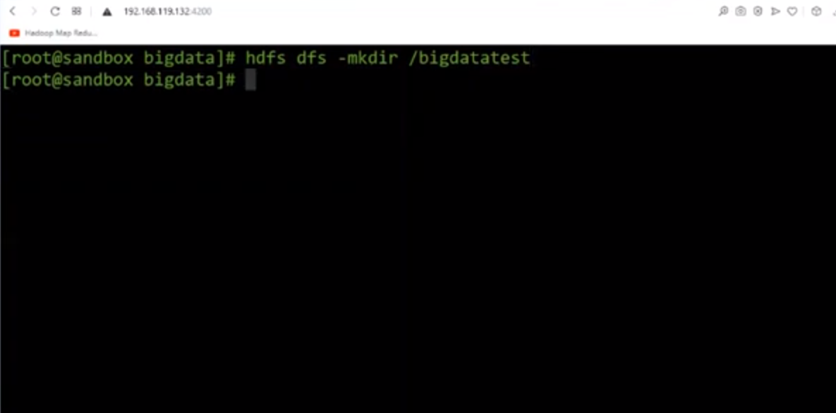

1. 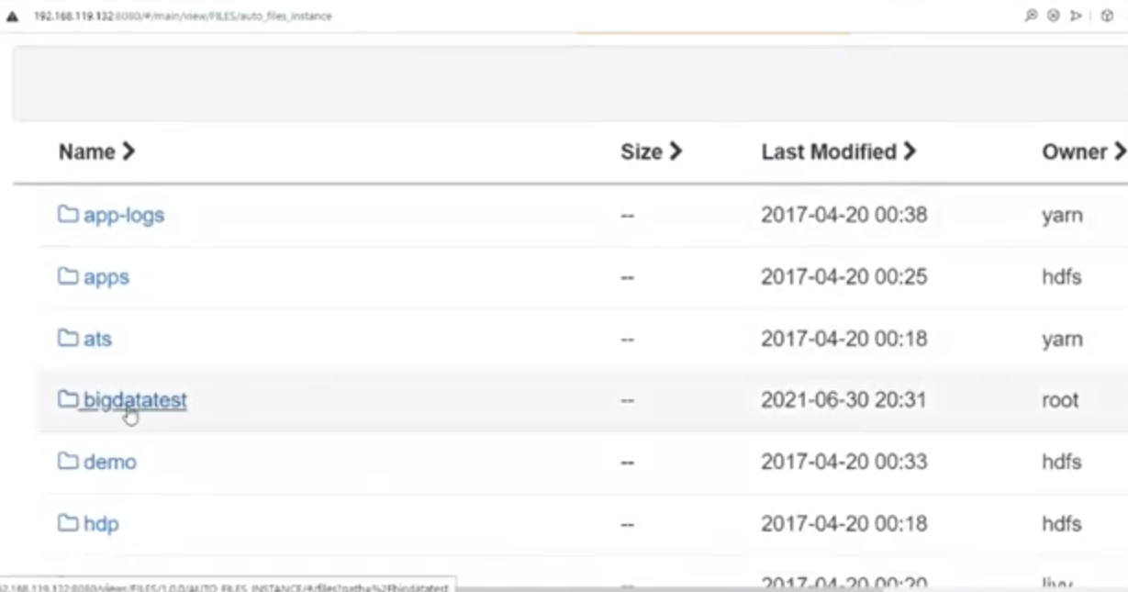Create a file in local directory

**Cat:** Create a file.

Cat>>

To terminate press ctrl+d

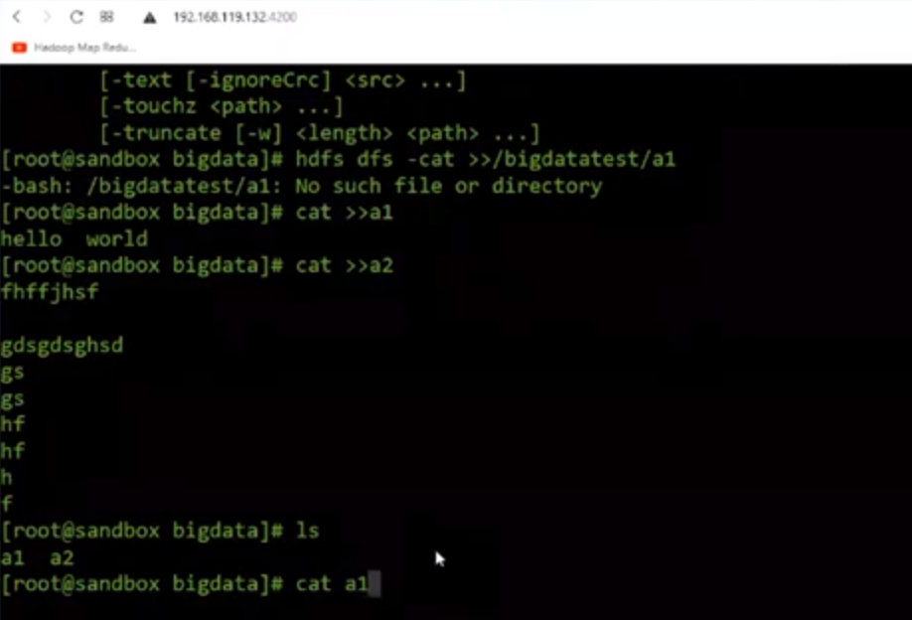

1. To upload files/directory to from local to HDFS

**Put:** to move a local file or directories into the distributed file systemCommand: hdfs dfs -put a1 /bigdatatest/ and hdfs dfs -put a2 /bigdatatest/ will upload both the files.

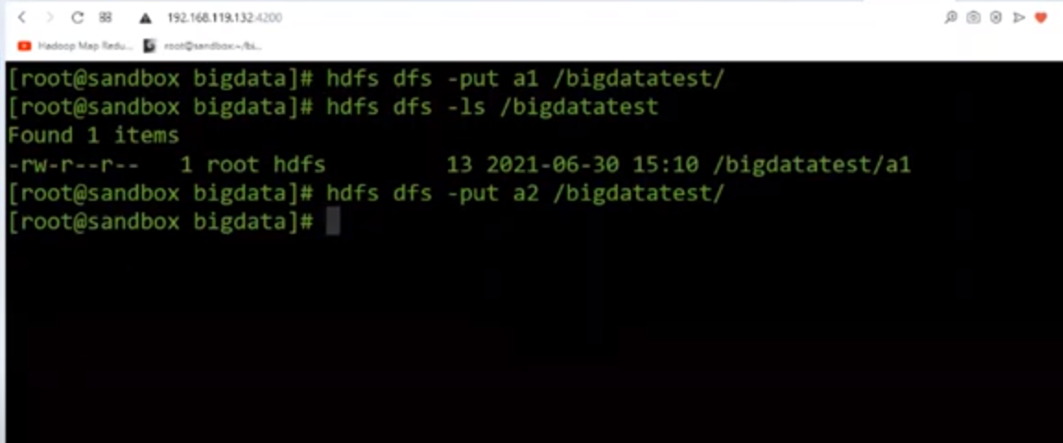Refresh the user interface we can see both the files.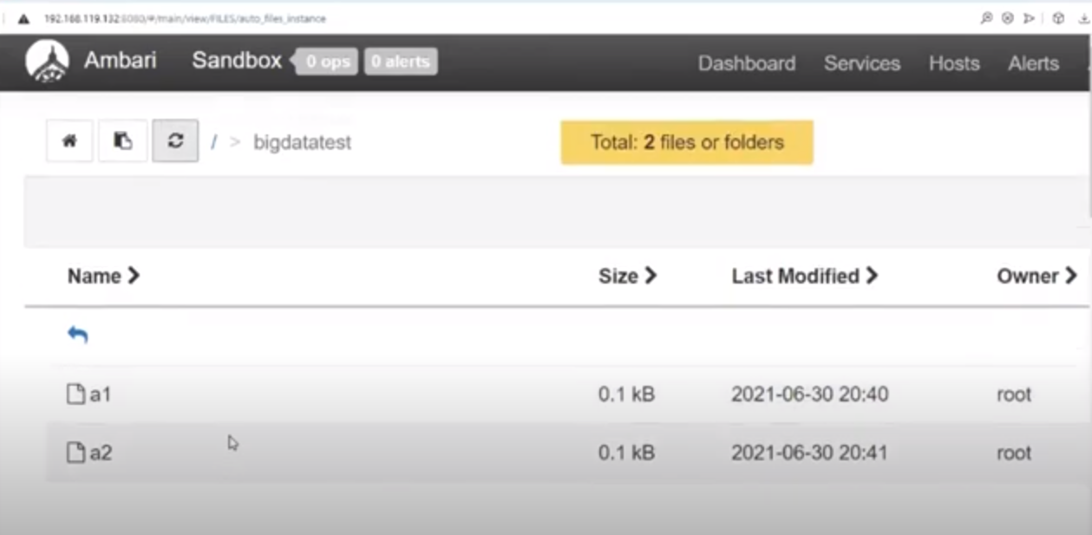To download files/directories to from hdfs to local**Get:** To copy files/folders from hdfs store to local file system.Command: hdfs dfs -get /bigdatatest/a1 and hdfs dfs -get /bigdatatest/ a2 will upload both the files.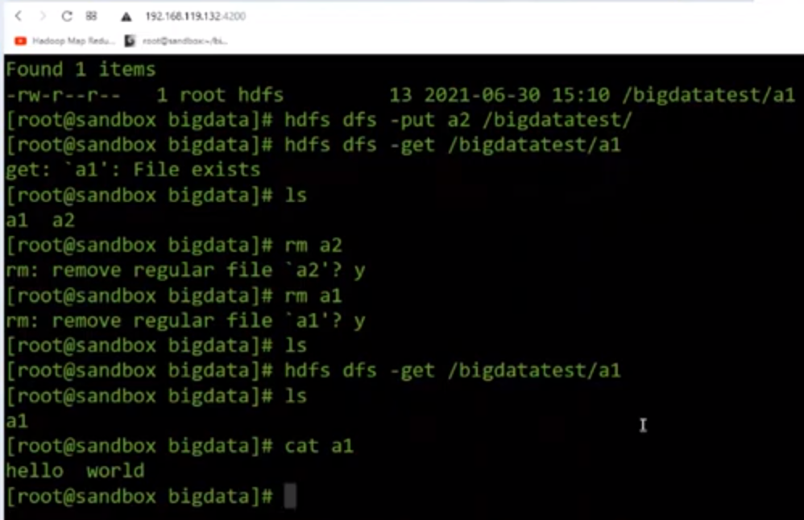

1. To remove file from local use rm command

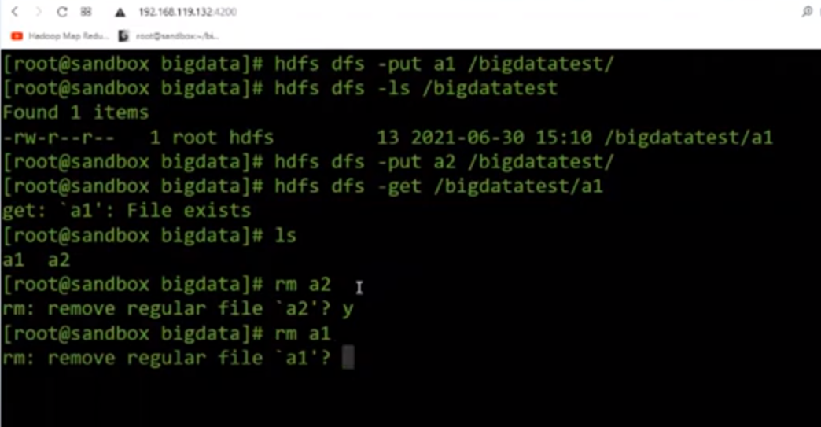

1. To remove file from Hadoop directory

Command: hdfs dfs -rm a2 /gibdatatest/a2

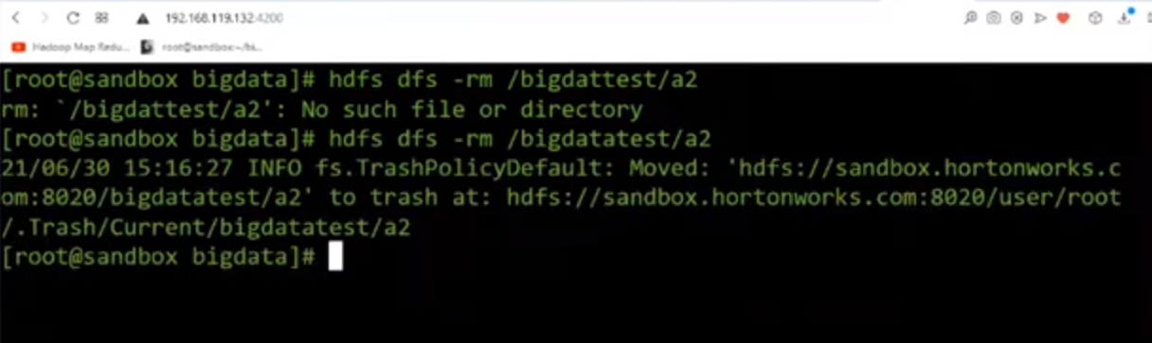

Now refresh the UI and the file will be deleted.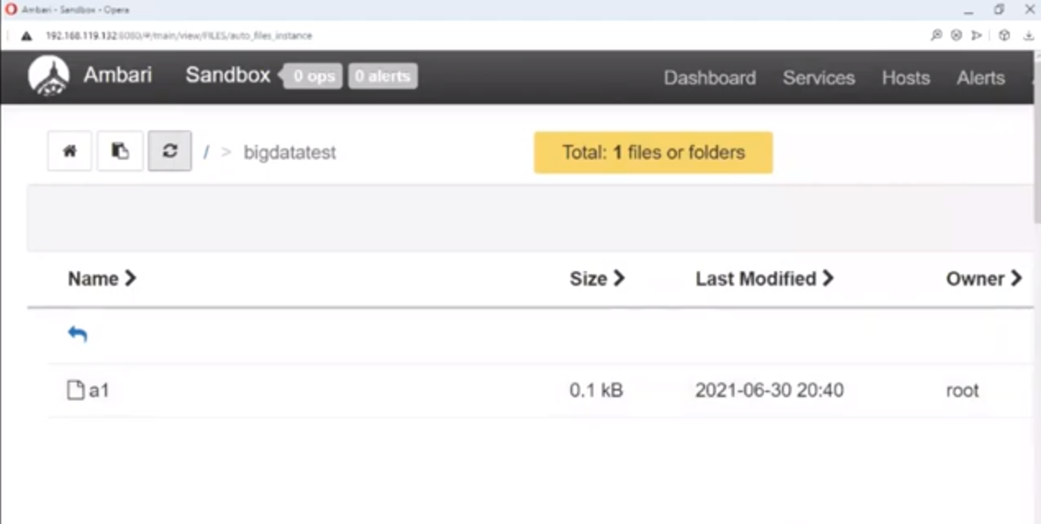

1. To download all the files from hdfs to local

Command: hdfs dfs -get /bigdatatest/*

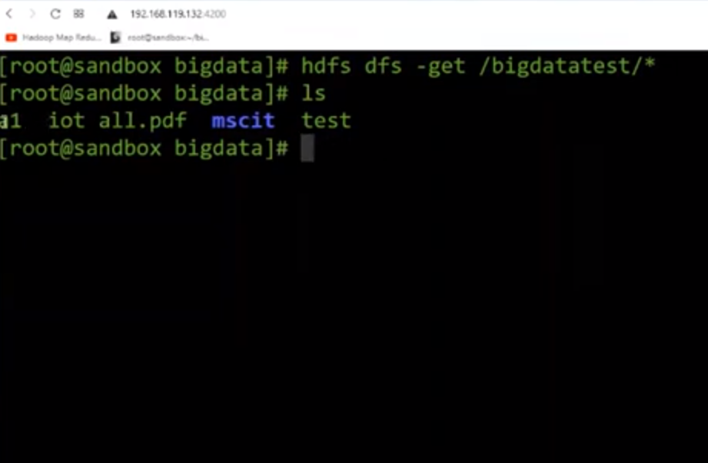

1. Change user and directory and change user only

Command: su – hdfs (Change user and directory)

Su hdfs (change user only)

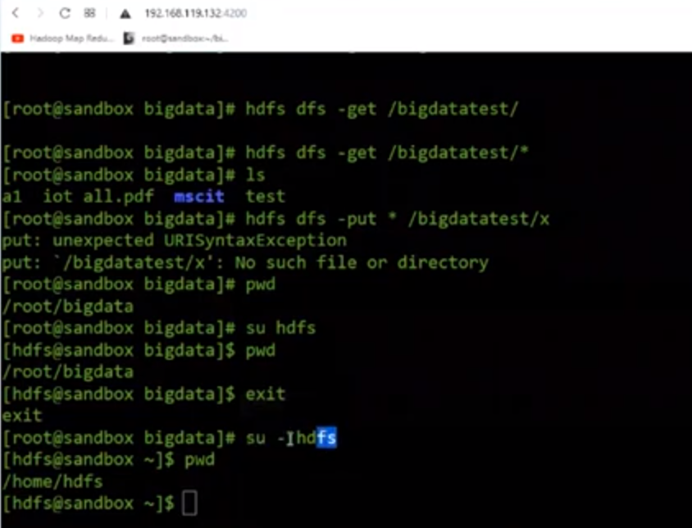

**Practical 2**

|  |
| --- |
| Implement word count / frequency programs using MapReduce |

Map Reduce as two component Map and Reduce.

**Java program:**

write program save as WordCount.java////////////////////////

import java.io.IOException;

import java.util.StringTokenizer;

import org.apache.hadoop.conf.Configuration;

import org.apache.hadoop.fs.Path;

import org.apache.hadoop.io.IntWritable;

import org.apache.hadoop.io.Text;

import org.apache.hadoop.mapreduce.Job;

import org.apache.hadoop.mapreduce.Mapper;

import org.apache.hadoop.mapreduce.Reducer;

import org.apache.hadoop.mapreduce.lib.input.FileInputFormat;

import org.apache.hadoop.mapreduce.lib.output.FileOutputFormat;

public class WordCount { public static class TokenizerMapper extends Mapper<Object, Text, Text, IntWritable>{

private final static IntWritable one = new IntWritable(1);

private Text word = new Text();

public void map(Object key, Text value, Context context

) throws IOException, InterruptedException {

StringTokenizer itr = new StringTokenizer(value.toString());

while (itr.hasMoreTokens()) {//"This is the output is the"

word.set(itr.nextToken());

context.write(word, one);

}

}

}

public static class IntSumReducer extends Reducer<Text,IntWritable,Text,IntWritable> {

private IntWritable result = new IntWritable();

public void reduce(Text key, Iterable<IntWritable> values, Context context) throws IOException,

InterruptedException

{//is,3

int sum = 0;

for (IntWritable val : values) {

sum += val.get();

}

result.set(sum);

context.write(key, result);

}

}public static void main(String[] args) throws Exception {

Configuration conf = new Configuration();

Job job = Job.getInstance(conf, "word count");

job.setJarByClass(WordCount.class);

job.setMapperClass(TokenizerMapper.class);

job.setCombinerClass(IntSumReducer.class);

job.setReducerClass(IntSumReducer.class);

job.setOutputKeyClass(Text.class);

job.setOutputValueClass(IntWritable.class);

FileInputFormat.addInputPath(job, new Path(args[0]));

FileOutputFormat.setOutputPath(job, new Path(args[1]));

System.exit(job.waitForCompletion(true)?0:1);

}

}

////////////////////////**Text File:**

Hello World

This is the output is theStart the server (Horton Sandbox)

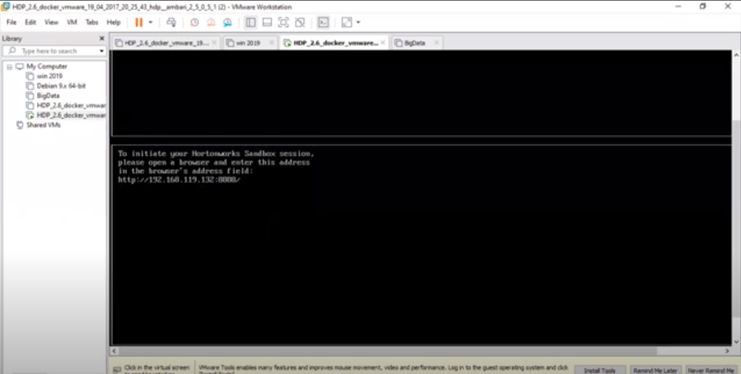

Open the terminal with 192.168.119.132/4200

Enter the login: root and the password and enter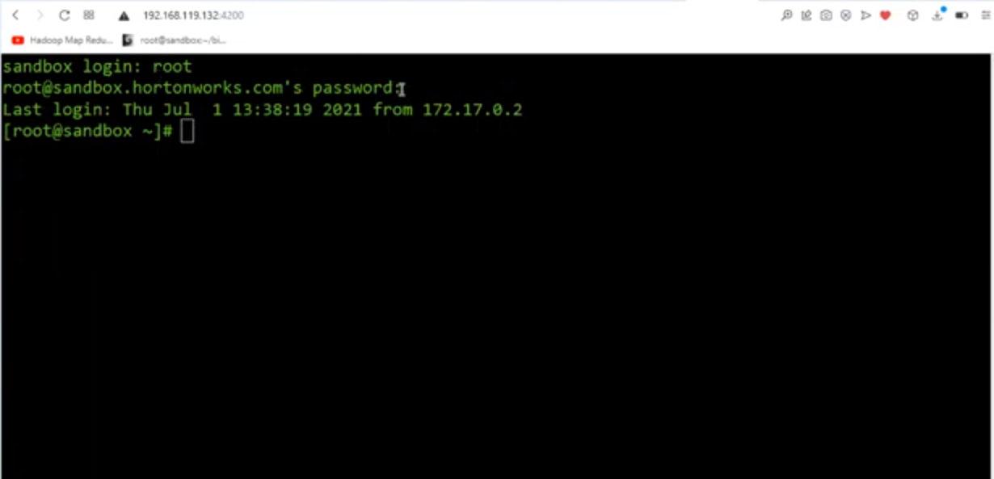

Create a folder in local directory.

Command: mkdir mscitp2

Change the directory cd mscitp2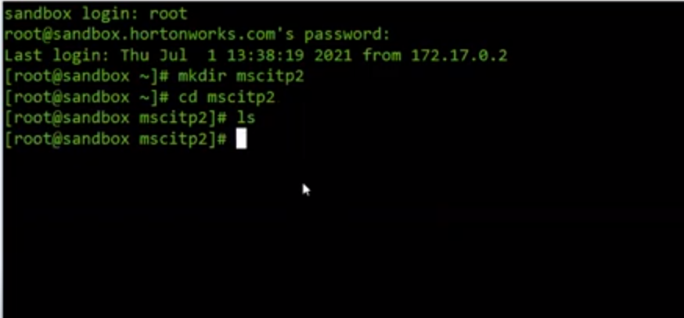

Now create input file

Command: cat >> wordin.txt

Paste the text by right clicking on terminal

Hello World

This is the output is the

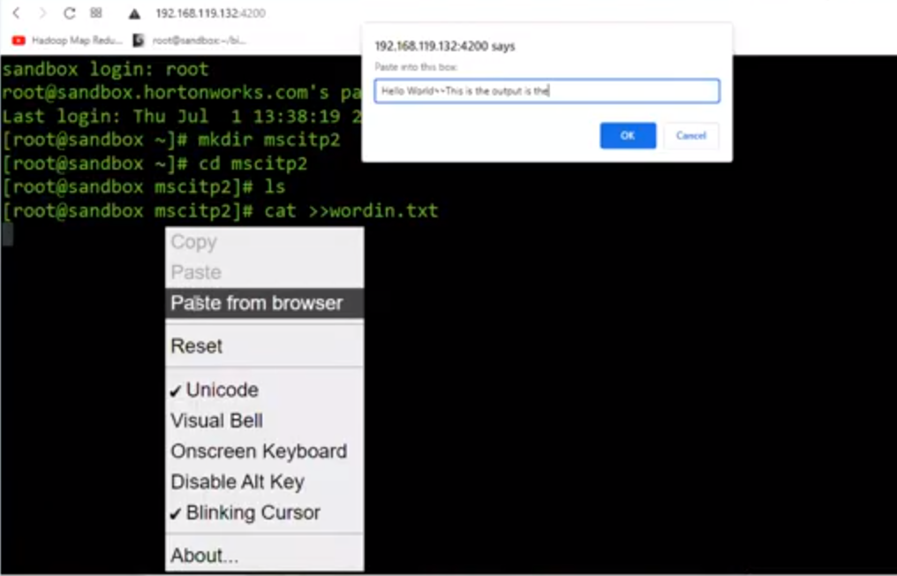

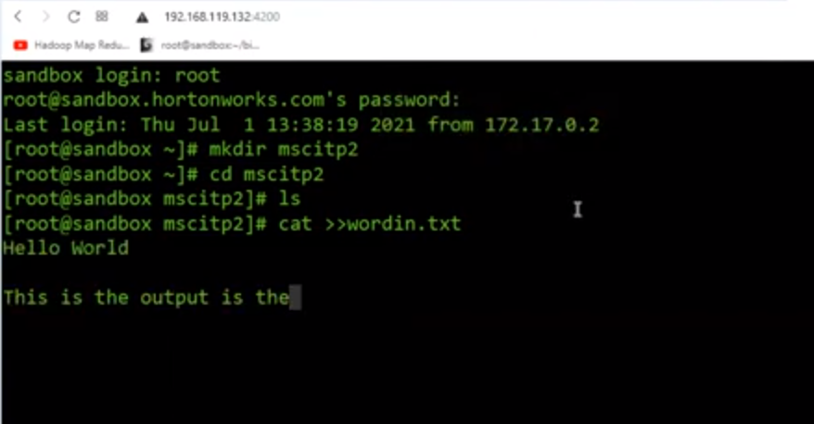

To remove the extra space type command

vi wordin.txt

After removing the extra space check the content of the file

cat wordin.txt

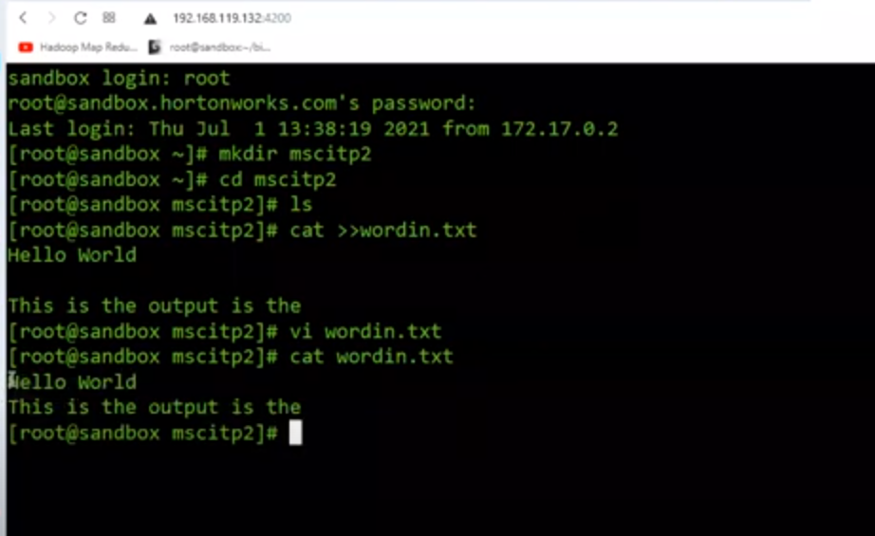

Create another file wordcount.java

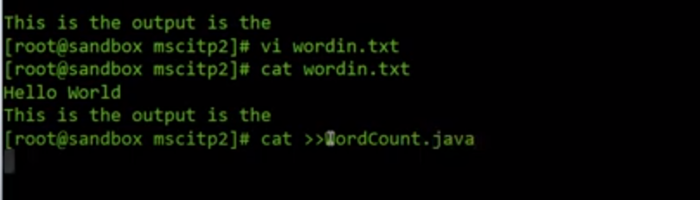

Paste the java code.

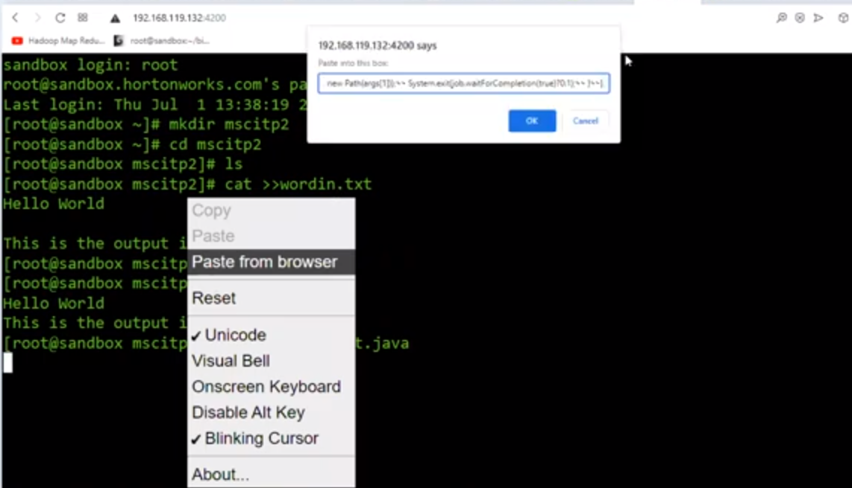

Press control d to save the file

Check both the files create with command ls

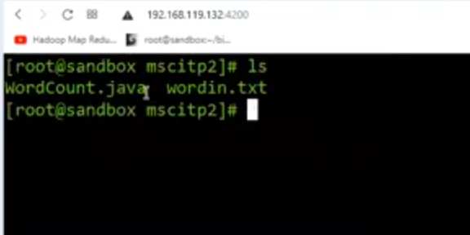

Now, to compile the java file

export HADOOP_CLASSPATH=$(hadoop classpath)

mkdir classes (To keep the compile files)

javac -classpath ${HADOOP_CLASSPATH} -d classes WordCount.java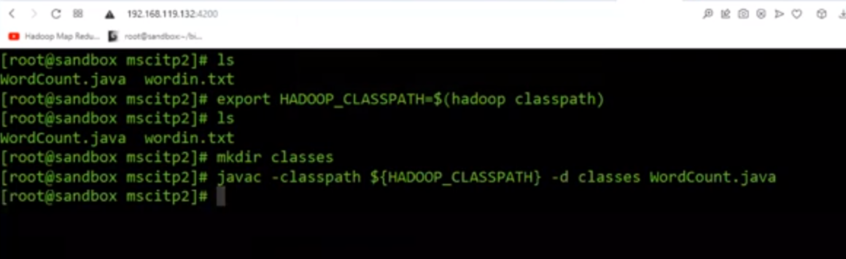Check class files are created with command ls classes

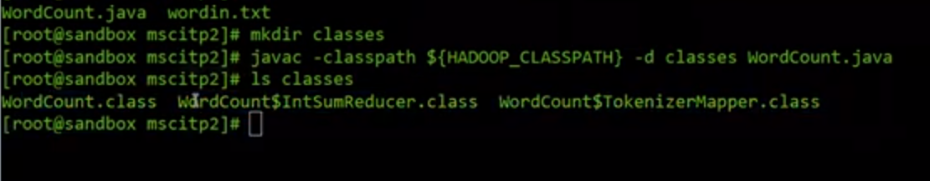

Now we have to bind all the class into single jar file with below command

jar -cvf WordCount.jar -C classes/ .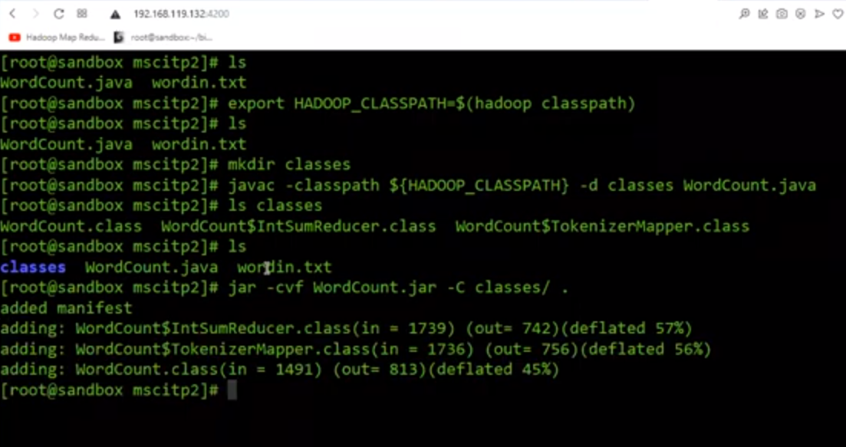Run ls command we can see jar file is created.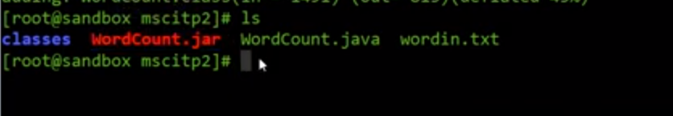wordin.txt should be present in word directory of hdfs. So we need to upload wordin.txt file.

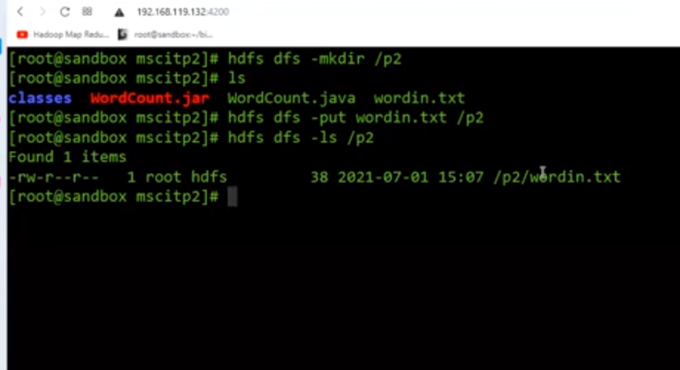We need to put the final output p2output.

hadoop jar WordCount.jar WordCount /p2/ /p2output

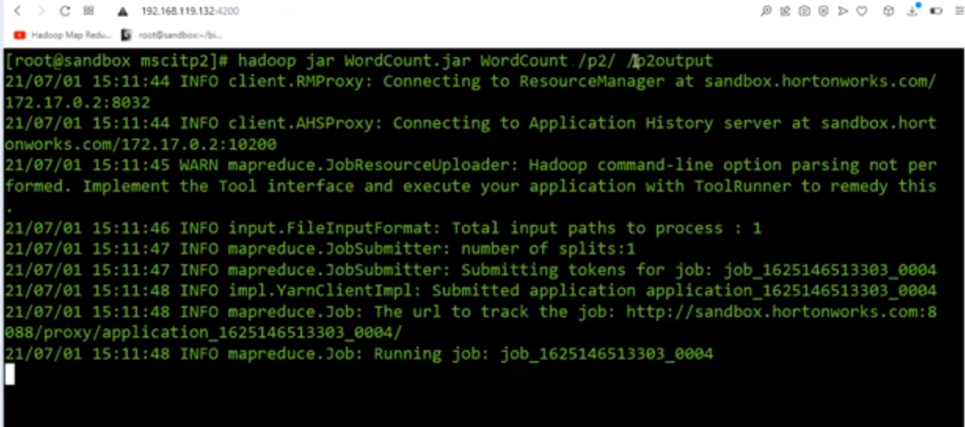

Print the content of the output file

Command: hdfs dfs -cat /p2ouput/*

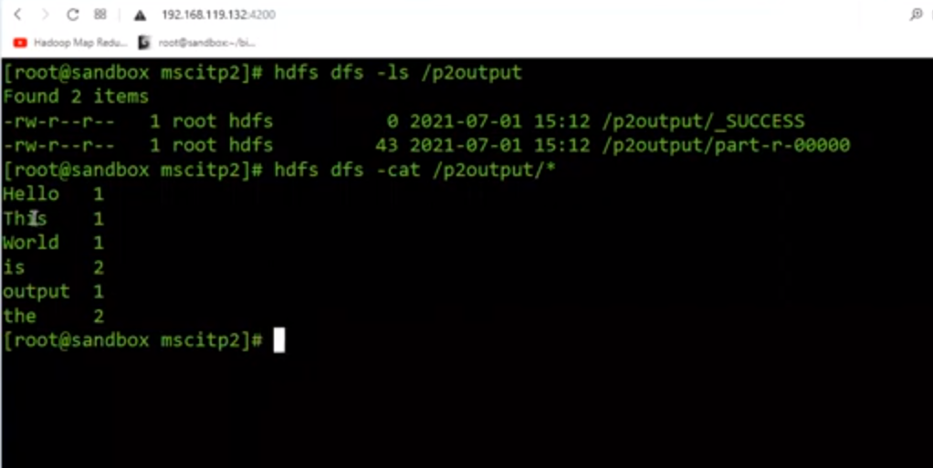

Ctrl + l to clear the screen.

vi filename.txt= this command will create/ open filename.txt

two modes of vi editor

1. Insert mode – i (press i key)
2. Command mode – esc key

:wq is to save and exit

**Practical 3**

|  |
| --- |
| Implement an MapReduce program that processes a weather dataset. |

**Java program:**

MyMaxMin.java

///////////////////////////

// importing Libraries

import java.io.IOException;

import java.util.Iterator;

import org.apache.hadoop.fs.Path;

import org.apache.hadoop.io.LongWritable;

import org.apache.hadoop.io.Text;

import org.apache.hadoop.mapreduce.lib.input.FileInputFormat;

import org.apache.hadoop.mapreduce.lib.output.FileOutputFormat;

import org.apache.hadoop.mapreduce.lib.output.TextOutputFormat;

import org.apache.hadoop.mapreduce.lib.input.TextInputFormat;

import org.apache.hadoop.mapreduce.Job;

import org.apache.hadoop.mapreduce.Mapper;

import org.apache.hadoop.mapreduce.Reducer;

import org.apache.hadoop.conf.Configuration;public class MyMaxMin {

// Mapper

/*MaxTemperatureMapper class is static

* and extends Mapper abstract class

* having four Hadoop generics type

* LongWritable, Text, Text, Text.

*/

public static class MaxTemperatureMapper extends

Mapper<LongWritable, Text, Text, Text> {

public static final int MISSING = 9999;

@Override

public void map(LongWritable arg0, Text Value, Context context)

throws IOException, InterruptedException {

String line = Value.toString();

// Check for the empty line

if (!(line.length() == 0)) {

// from character 6 to 14 we have

// the date in our dataset

String date = line.substring(6, 14); // similarly we have taken the maximum

// temperature from 39 to 45 characters

float temp_Max = Float.parseFloat(line.substring(39, 45).trim());

// similarly we have taken the minimum

// temperature from 47 to 53 characters

float temp_Min = Float.parseFloat(line.substring(47, 53).trim()); // if maximum temperature is

// greater than 30, it is a hot day

if (temp_Max > 30.0) {

// Hot day

context.write(new Text("The Day is Hot Day :" + date),

new Text(String.valueOf(temp_Max)));

} // if the minimum temperature is

// less than 15, it is a cold day

if (temp_Min < 15) {

// Cold day

context.write(new Text("The Day is Cold Day :" + date),

new Text(String.valueOf(temp_Min)));

}

}

} }// Reducer

/*MaxTemperatureReducer class is static

and extends Reducer abstract class

having four Hadoop generics type

Text, Text, Text, Text.

*/

//The Day is Cold Day :20150101 ,-21.8

public static class MaxTemperatureReducer extends

Reducer<Text, Text, Text, Text> { /**

* @method reduce

* This method takes the input as key and

* list of values pair from the mapper,

* it does aggregation based on keys and

* produces the final context.

*/

public void reduce(Text Key, Iterator<Text> Values, Context context)

throws IOException, InterruptedException {

// putting all the values in

// temperature variable of type String

String temperature = Values.next().toString();

context.write(Key, new Text(temperature));

} } /**

* @method main

* This method is used for setting

* all the configuration properties.

* It acts as a driver for map-reduce

* code.

*/

public static void main(String[] args) throws Exception { // reads the default configuration of the

// cluster from the configuration XML files

Configuration conf = new Configuration();

// Initializing the job with the

// default configuration of the cluster

Job job = new Job(conf, "weather example");

// Assigning the driver class name

job.setJarByClass(MyMaxMin.class); // Key type coming out of mapper

job.setMapOutputKeyClass(Text.class);

// value type coming out of mapper

job.setMapOutputValueClass(Text.class); // Defining the mapper class name

job.setMapperClass(MaxTemperatureMapper.class);

// Defining the reducer class name

job.setReducerClass(MaxTemperatureReducer.class); // Defining input Format class which is

// responsible to parse the dataset

// into a key value pair

job.setInputFormatClass(TextInputFormat.class);

// Defining output Format class which is

// responsible to parse the dataset

// into a key value pair

job.setOutputFormatClass(TextOutputFormat.class); // setting the second argument

// as a path in a path variable

Path OutputPath = new Path(args[1]); // Configuring the input path

// from the filesystem into the job

FileInputFormat.addInputPath(job, new Path(args[0])); // Configuring the output path from

// the filesystem into the job

FileOutputFormat.setOutputPath(job, new Path(args[1])); // deleting the context path automatically

// from hdfs so that we don't have

// to delete it explicitly

OutputPath.getFileSystem(conf).delete(OutputPath);

// flag value becomes false

System.exit(job.waitForCompletion(true) ? 0 : 1); }

}

/////////////////////Start the server

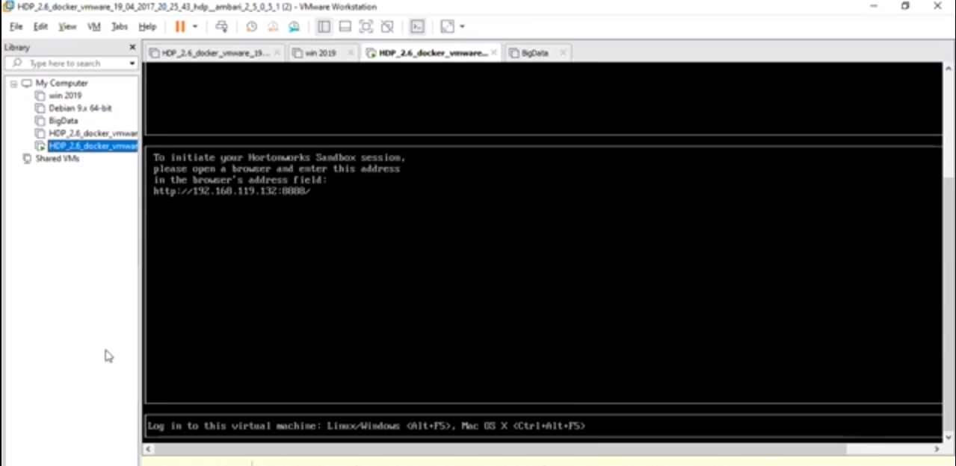Open the terminal with 192.168.119.132/4200

Enter the login: root and the password and enter



Create a folder in local directory.

Command: mkdir mscitp3

Change the directory cd mscitp3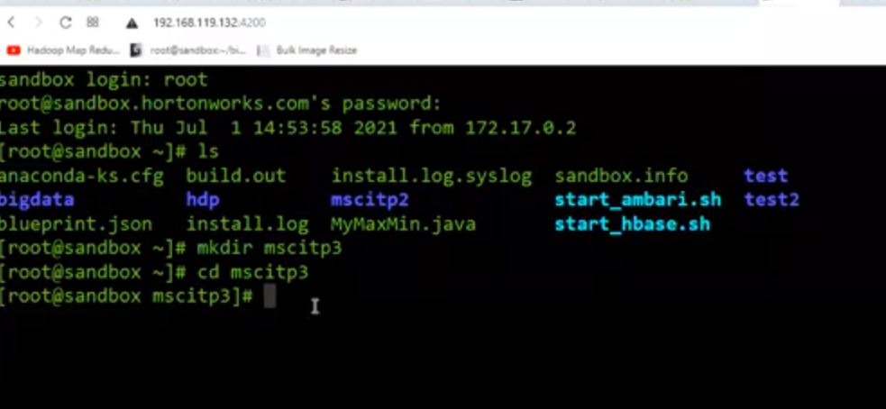

Now create input file

Command: cat >> weatherin2.txt

Paste the weather dataset by right clicking on terminal

Ctrl d will save the file

Run command ls to see the file.

Create java file

Command: cat >>MyMaxMin.java

Paste the java code and ctrl d to save the file

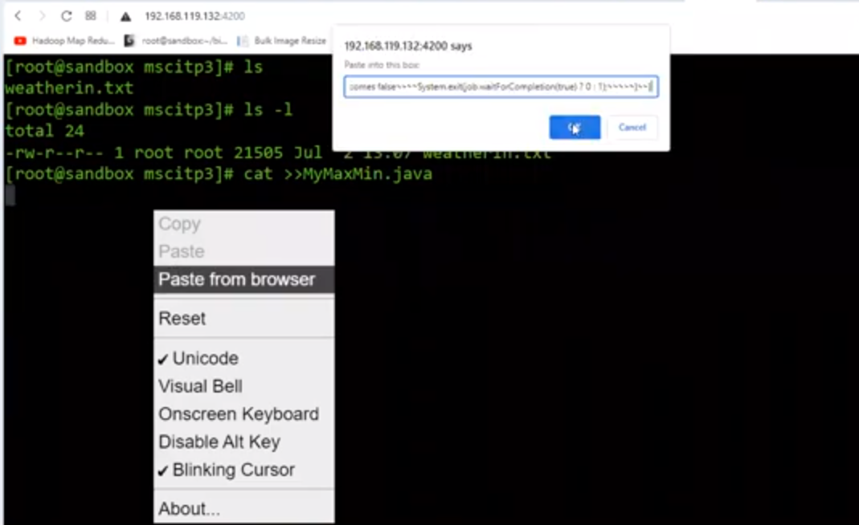

export HADOOP_CLASSPATH=$(hadoop classpath) ////compile and to create jar file

mkdir classes

javac -classpath ${HADOOP_CLASSPATH} -d classes MyMaxMin.java

After compile need to create a jar file

jar -cvf MyMaxMin.jar -C classes/ .

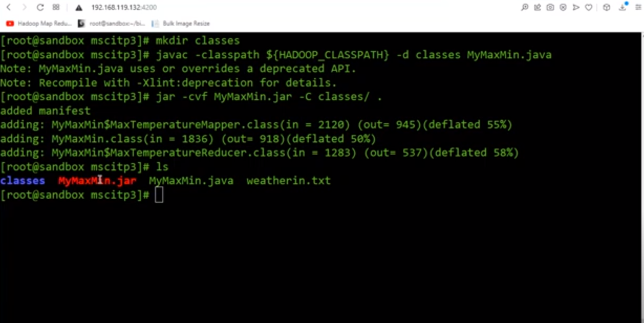

Now, put weatherin.txt in hdfs

Before that create a folder

Command: hdfs dfs -mkdir /p3input123

Then run command: hdfs dfs -put weatherin2.txt /p3input123

hadoop jar MyMaxMin.jar MyMaxMin /p3inputw /output123

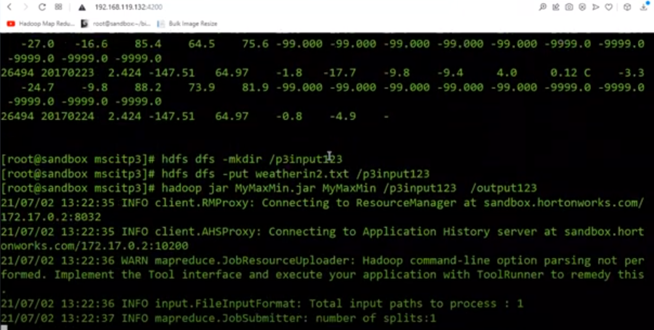

Check outfile is created

Command: hdfs dfs -ls /output123

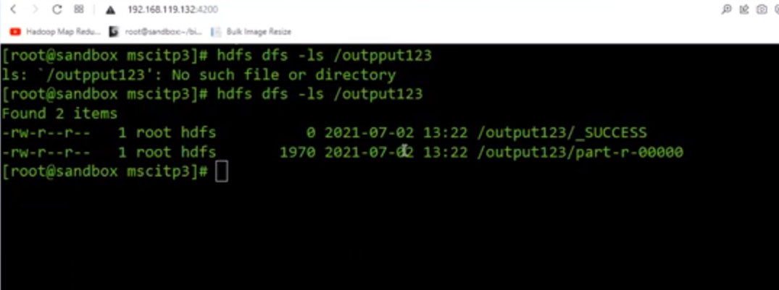

hdfs dfs -cat /output123/*

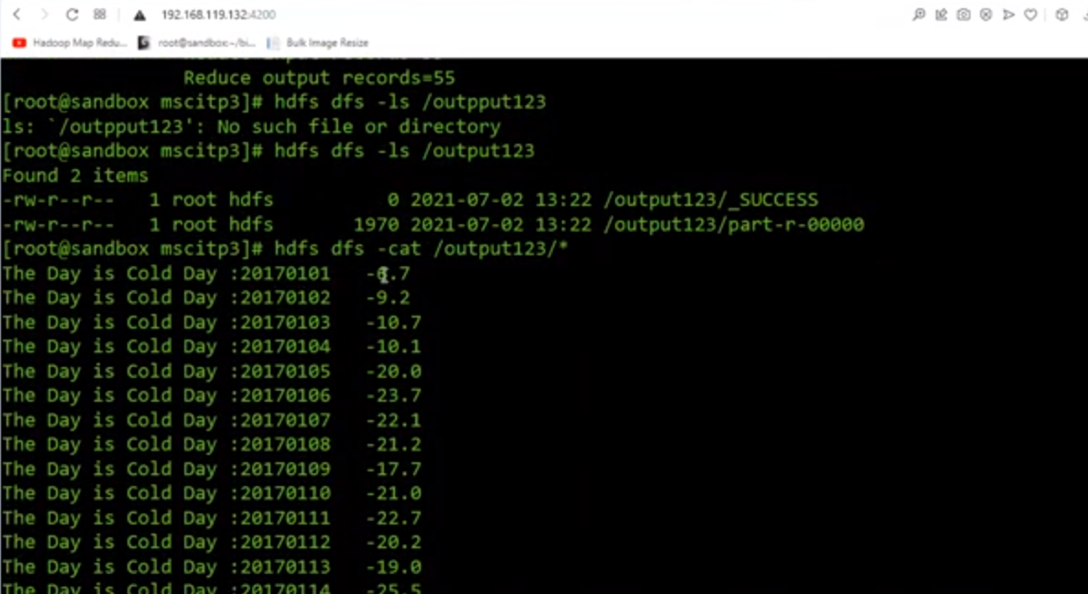

**Practical 4**

|  |
| --- |
| Implement the program using Pig. |

Dataset:

001,Rajiv,Reddy,21,9848022337,Hyderabad

002,siddarth,Battacharya,22,9848022338,Kolkata

003,Rajesh,Khanna,22,9848022339,Delhi

004,Preethi,Agarwal,21,9848022330,Pune

005,Trupthi,Mohanthy,23,9848022336,Bhuwaneshwar

006,Archana,Mishra,23,9848022335,Chennai

007,Komal,Nayak,24,9848022334,trivendram

008,Bharathi,Nambiayar,24,9848022333,Chennai

#student.txtcreate a directory and get into that directory

Command: mkdir p5mscit

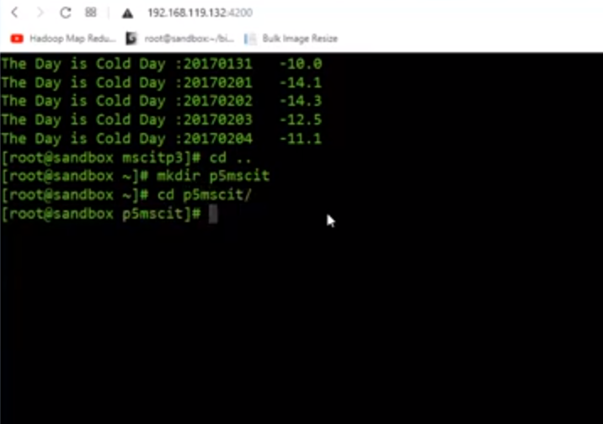Create a file

Command: cat >>student.txt

Right click and paste the text

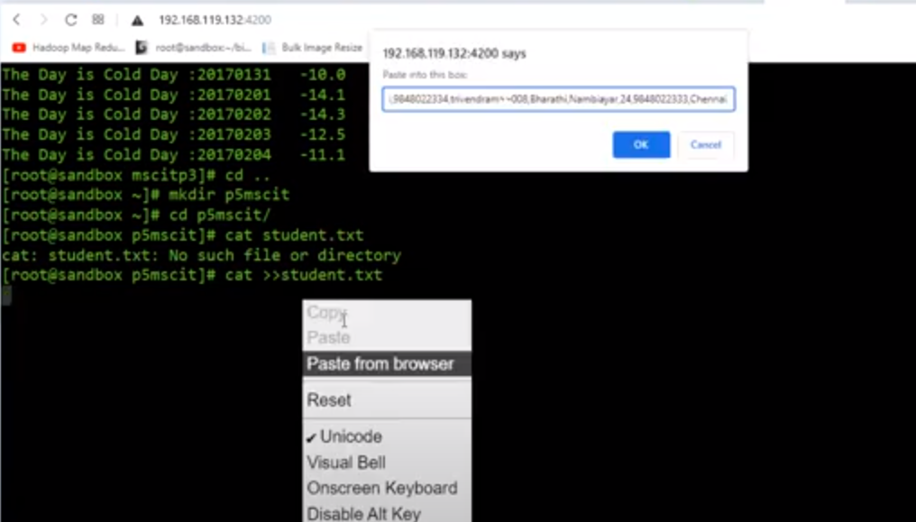

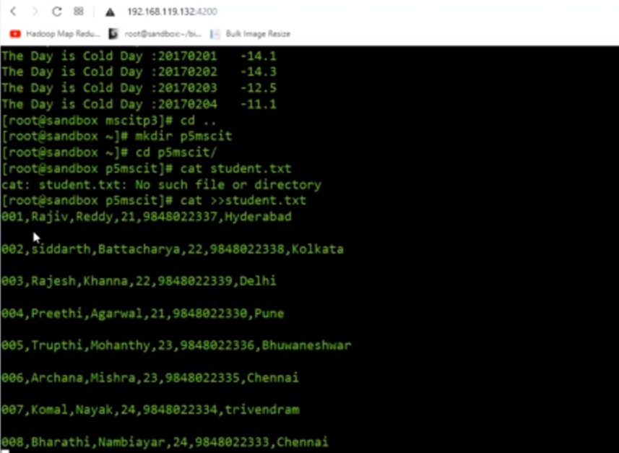

Remove the space with vi editor

Command: vi student.txt and press i for insert mode

After editing: wq and enter

Print the content and see the text

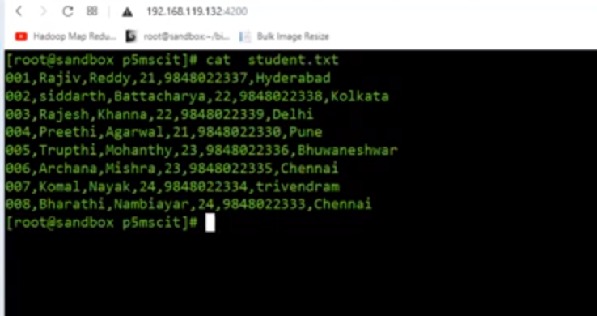Create a program file

/////////////////////////script start

student = LOAD 'student.txt' USING PigStorage(',')

as (id:int, firstname:chararray, lastname:chararray, age:int, phone:chararray, city:chararray);

student_order = ORDER student BY age DESC;student_limit = LIMIT student_order 4;Dump student_limit;

////////script end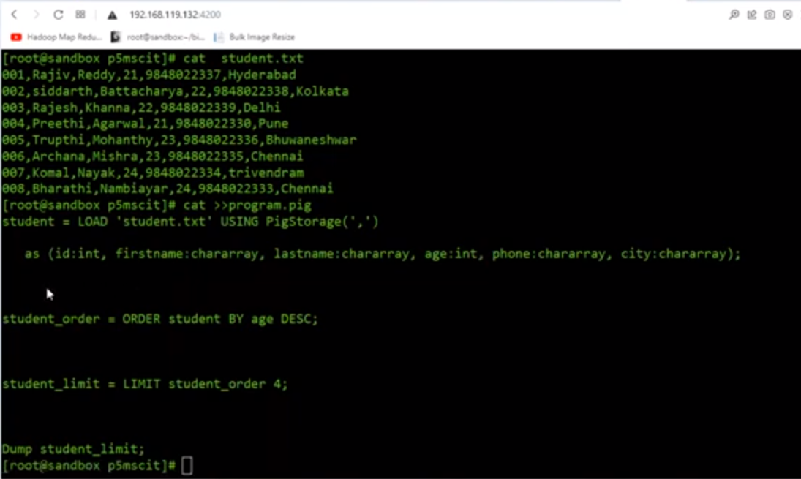

Upload student on hdfs

Command: hdfs dfs -put student.txt /user/root/

Run the pig program

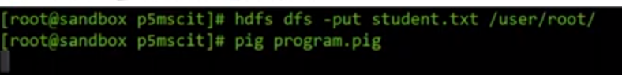

Output:

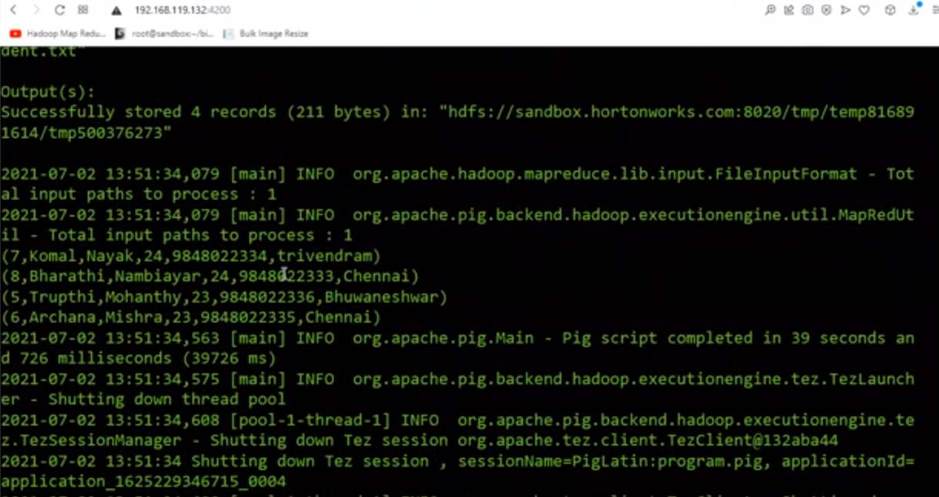

**Practical 5**

|  |
| --- |
| Implement the application in Hive. |

Dataset:

001,Rajiv,Reddy,21,9848022337,Hyderabad

002,siddarth,Battacharya,22,9848022338,Kolkata

003,Rajesh,Khanna,22,9848022339,Delhi

004,Preethi,Agarwal,21,9848022330,Pune

005,Trupthi,Mohanthy,23,9848022336,Bhuwaneshwar

006,Archana,Mishra,23,9848022335,Chennai

007,Komal,Nayak,24,9848022334,trivendram

008,Bharathi,Nambiayar,24,9848022333,Chennai

#student.txtcreate a directory and get into that directory

Command: mkdir p6mscit

Create a file

Command: cat >>data.txt

Right click and paste the text

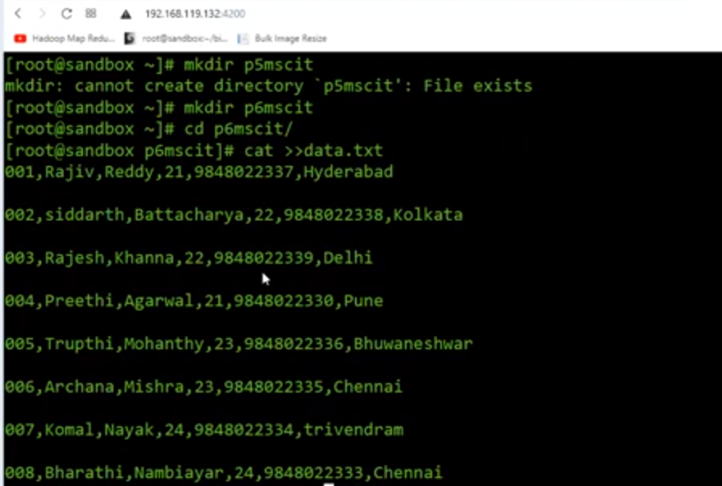Remove the space with vi editor

Command: vi student.txt and press i for insert mode

After editing: wq and enter

Print the content and see the text

Now start the hive terminal

Command: hive

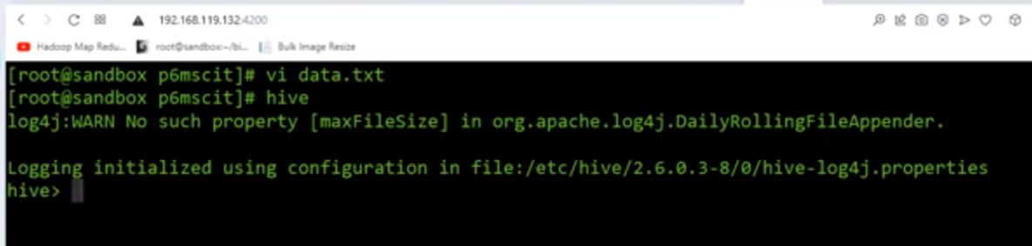

Copy paste below command on hive and entercreate table

CREATE TABLE IF NOT EXISTS employee ( eid int, fname String,

lname String, age int, contact String, city String)

COMMENT 'Employee details'

ROW FORMAT DELIMITED

FIELDS TERMINATED BY ','

LINES TERMINATED BY '\n'

STORED AS TEXTFILE;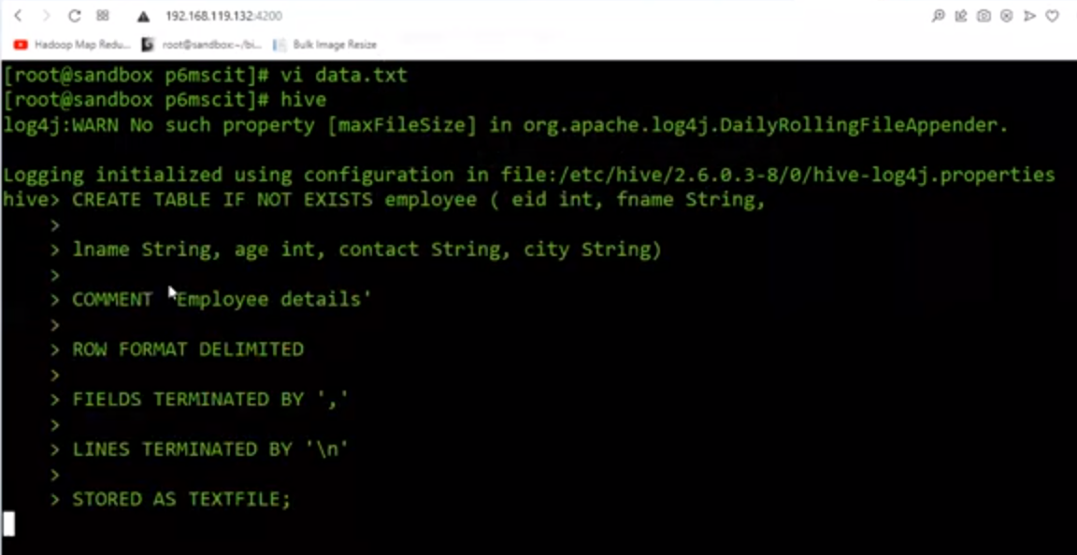Run command: LOAD DATA LOCAL INPATH 'data.txt' OVERWRITE INTO TABLE employee;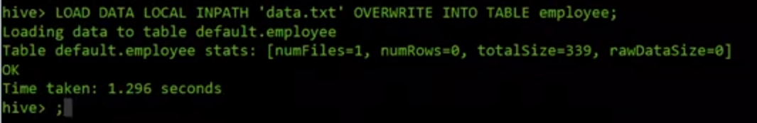

Run the command like select * from employee;

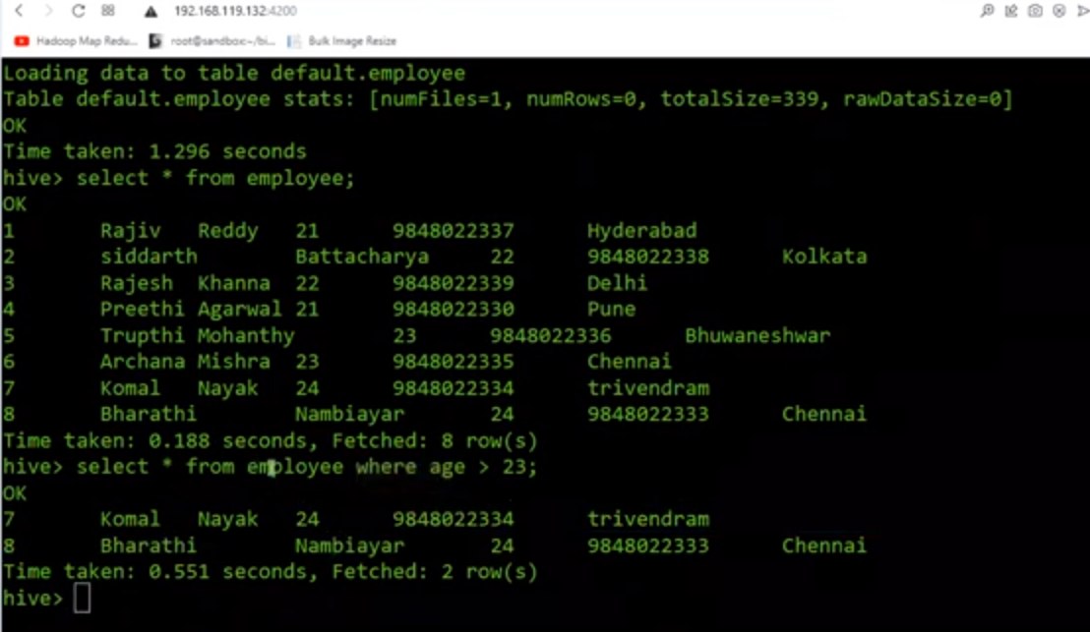

**Practical 6**

|  |
| --- |
| Implement an application that stores big data in Hbase/ Python |

What is HBase?

HBase is a distributed column-oriented database built on top of the Hadoop file system. It is an open-source project and is horizontally scalable.It is a part of the Hadoop ecosystem that provides random real-time read/write access to data in the Hadoop File System.Go to GUI page and start the hbase service.

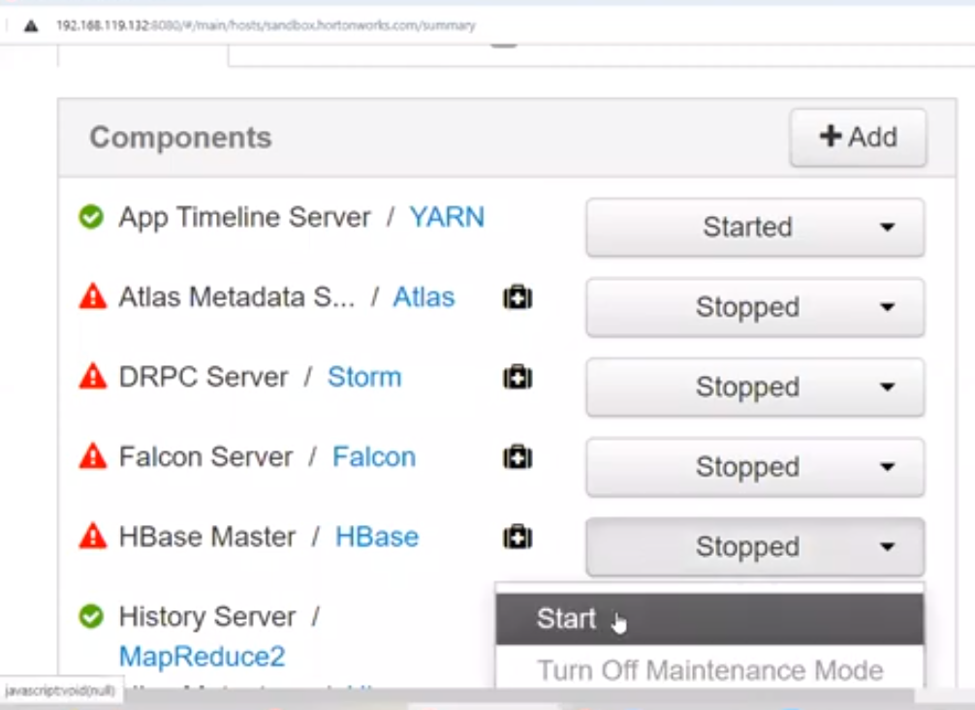

Click on OK to start the service.

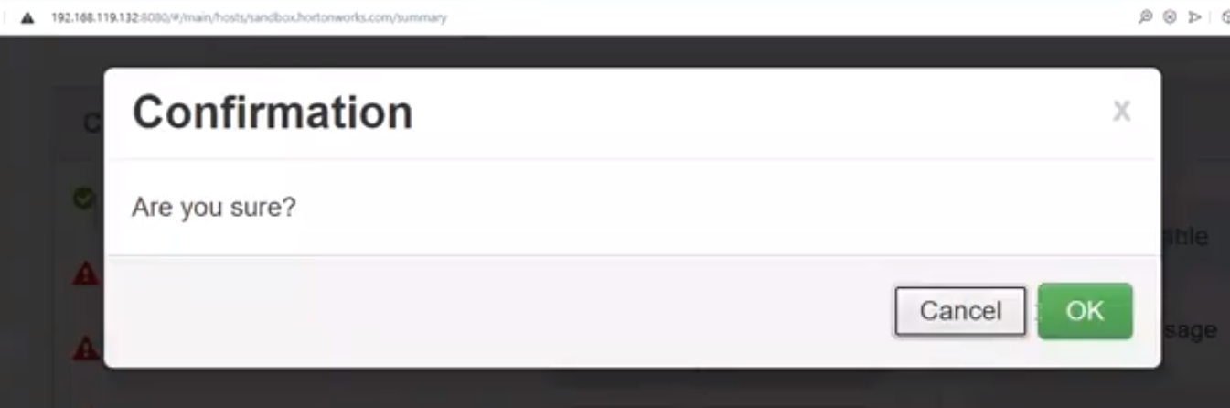

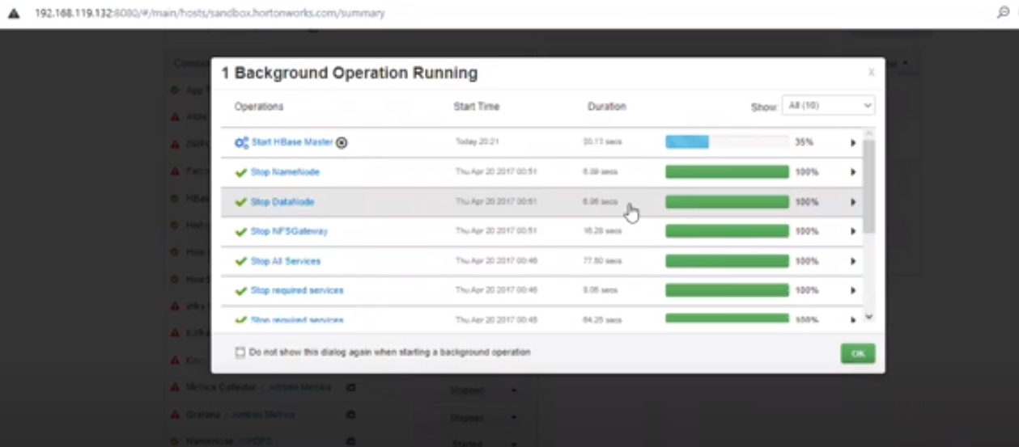

Now we must start region server.

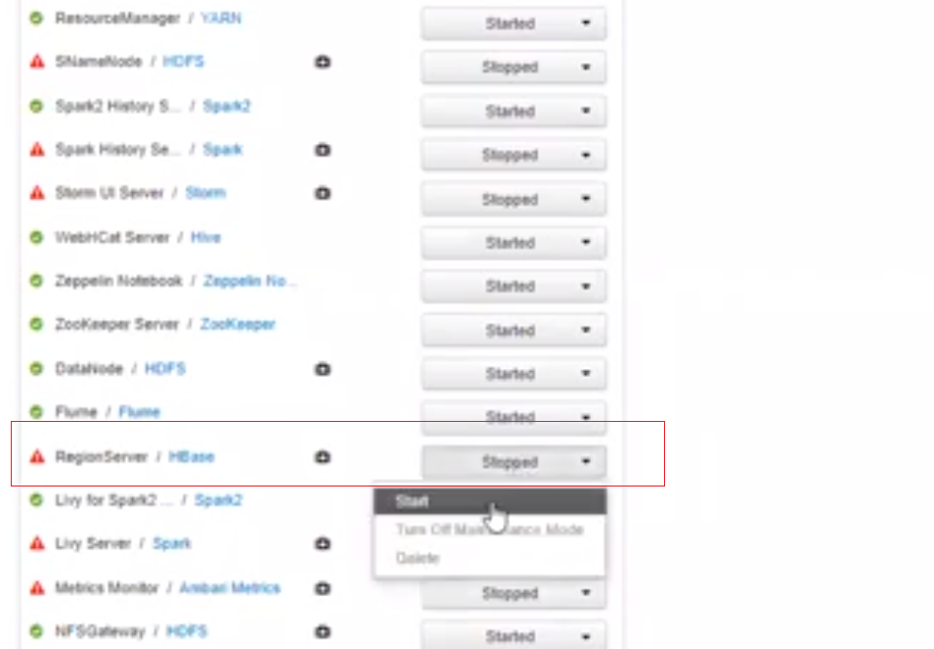

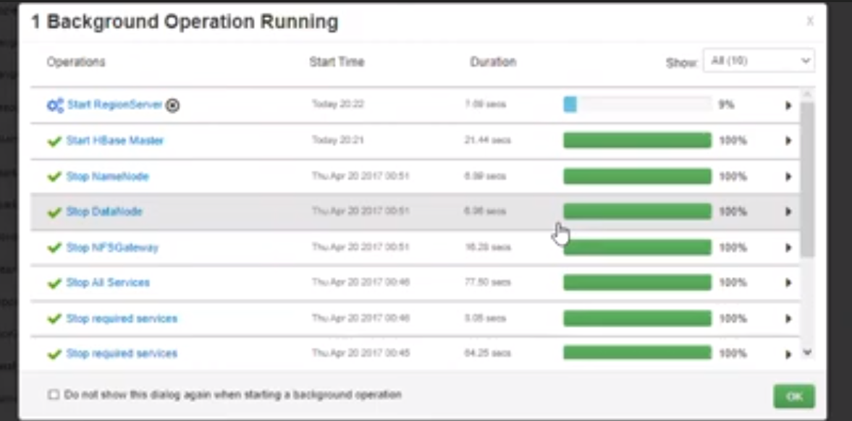

Check zooperkeeper server is started.

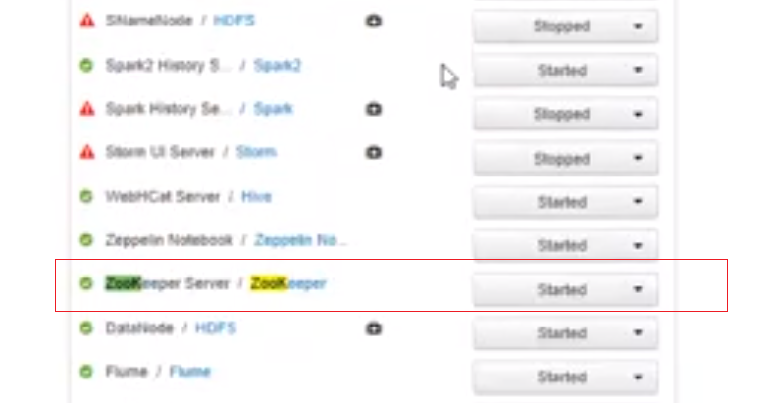

Check hbase and region server are started.

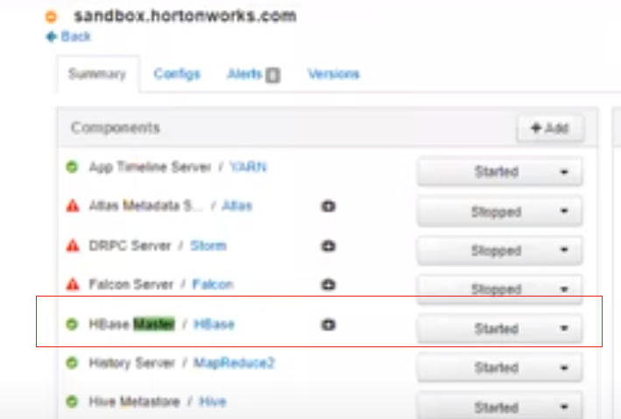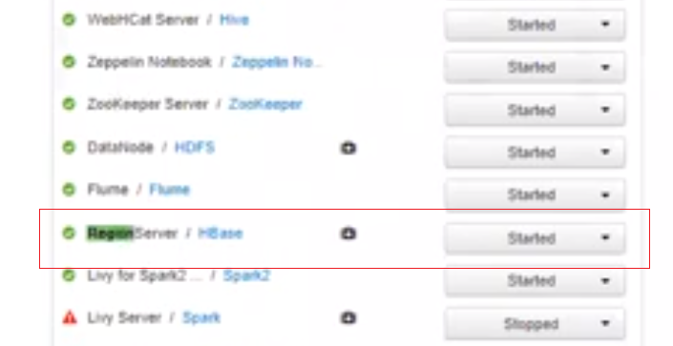

Command: **whichapplication-name** gives directory in which application-name is installed.

Open the shell

192.168.119.132:4200

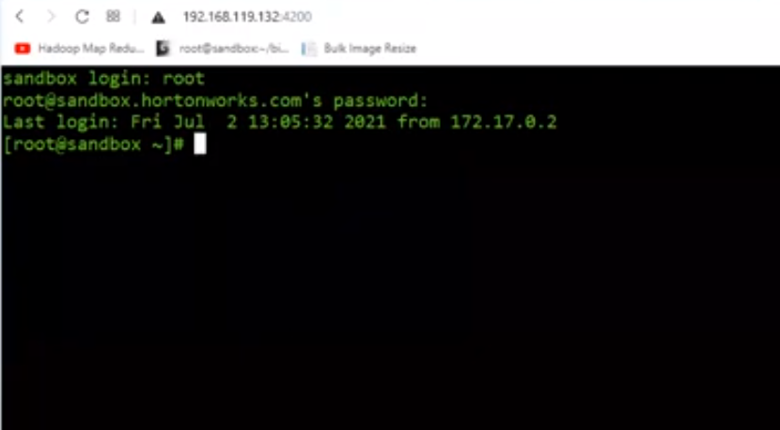Command: hbase shell

It will start the server

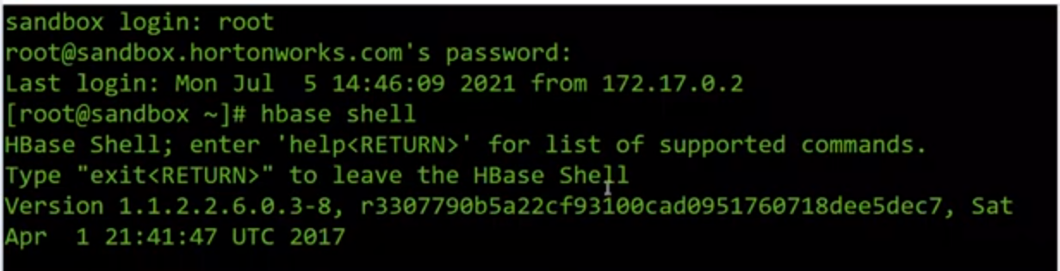

Enter the command create ‘test’, ‘cf’ and it will create the table

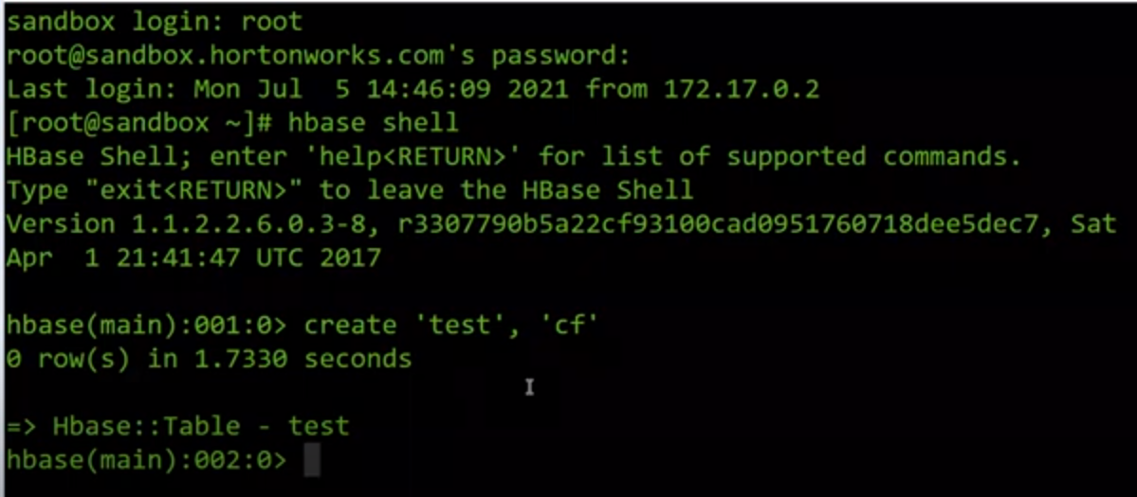

Check the table is created with command

List- It will list all the tables created.

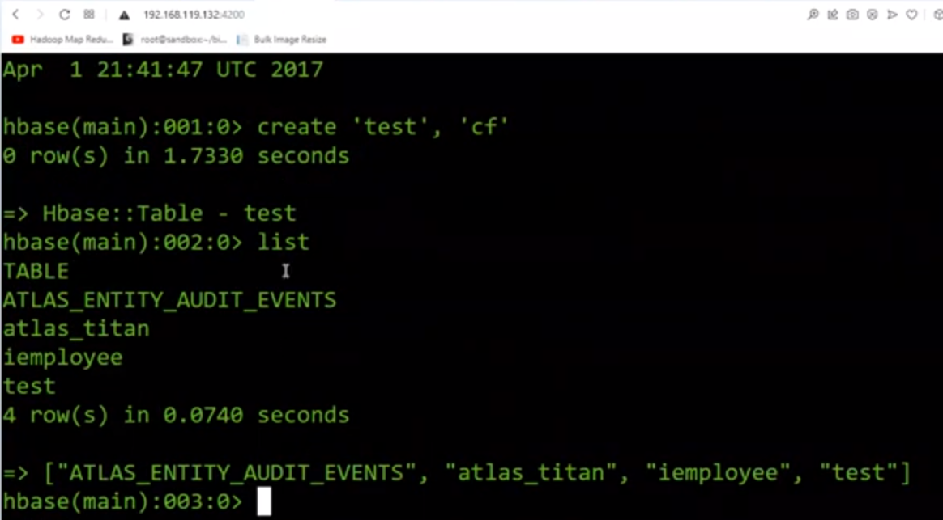

If we want to see column description of a table.

Command- describe tablename

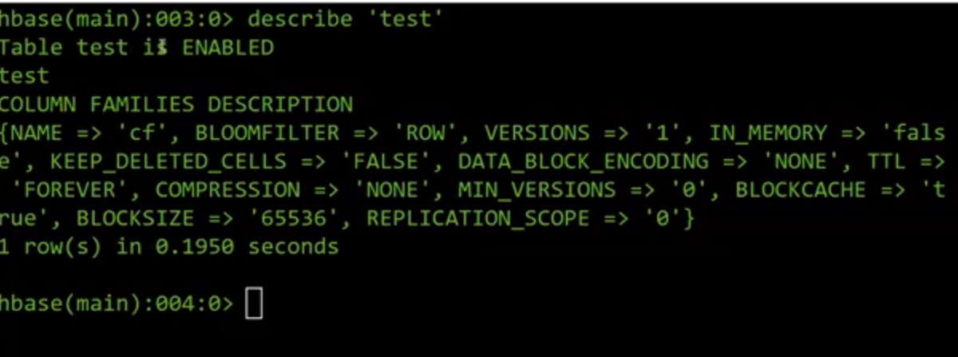

Now, we have to put the values in table

Values:

put ‘test’, ‘row1’, ‘cf:a’, ‘value1’

put ‘test’, ‘row2’, ‘cf:b’, ‘value2’

put ‘test’, ‘row3’, ‘cf:c’, ‘value3’

copy paste the data in shell.

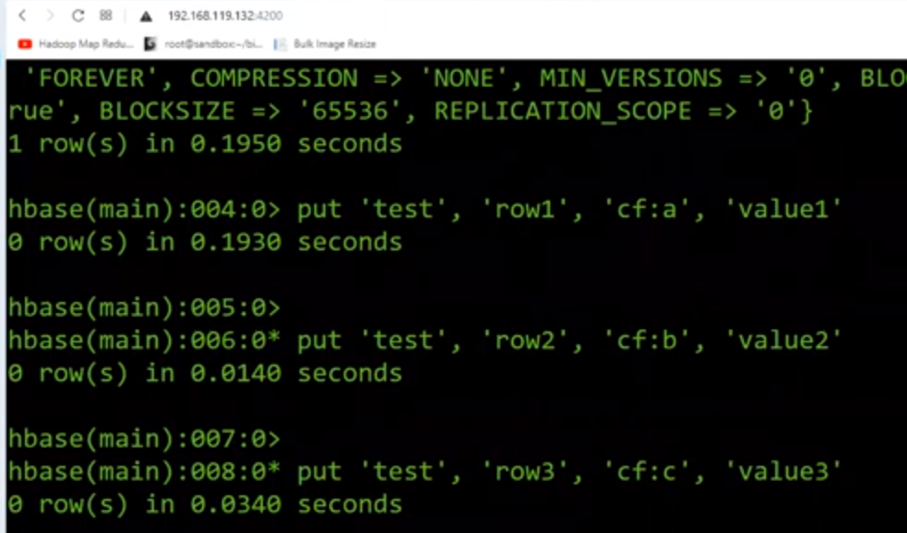

We to display the records of table

Command: scan ‘test’

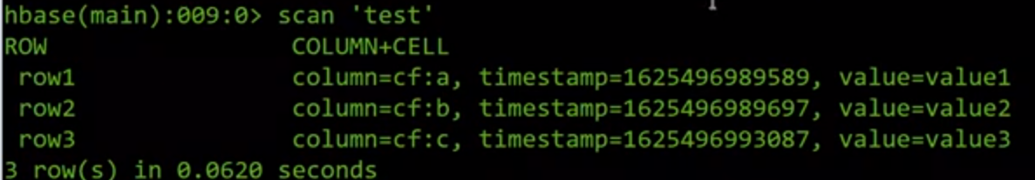**Python: storage/retrieval**

Start the service with command

Hbase thrift start -p 9090 –inforport 9095

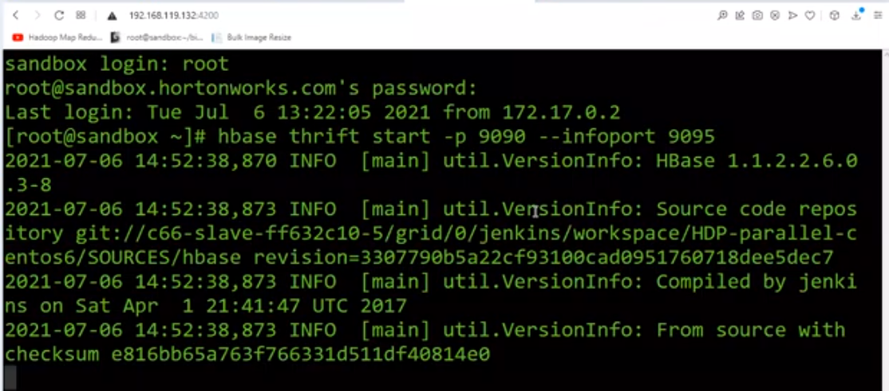

Create the table the way we did it in hbase and see the records using scan command

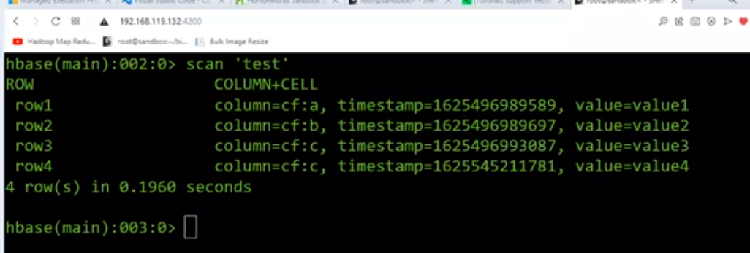

Create a program file

Import happybase as hb

conn=hb.connection(‘192.168.119.132’, 9090)

print(conn.table(‘test’).row(‘row1’)

print(conn.table(‘test’).row(‘row2’)

print(conn.table(‘test’).row(‘row3’)

print(conn.table(‘test’).row(‘row4’)

table = conn.table(‘test’)

table.put(b’row5’, {b’cf:r’: b’value5’})

print(conn.table(‘test’).row(‘row5’)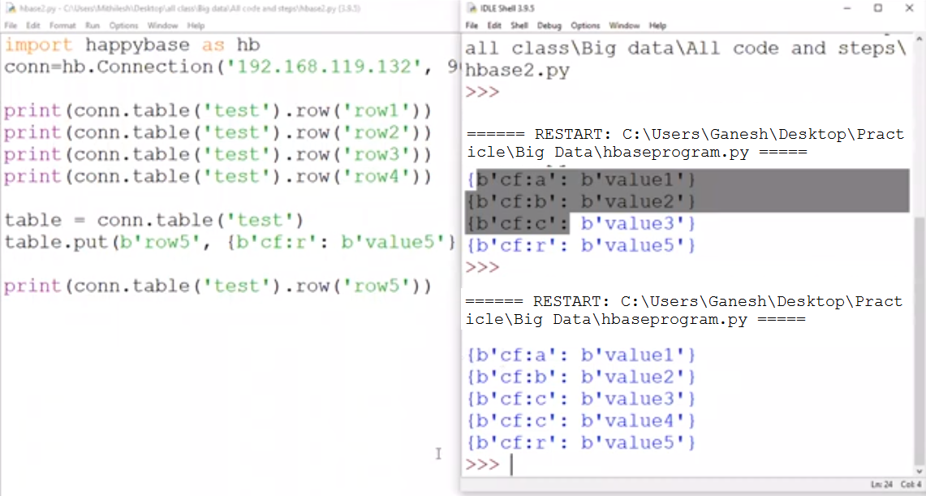Run a scan command on shell to display the values

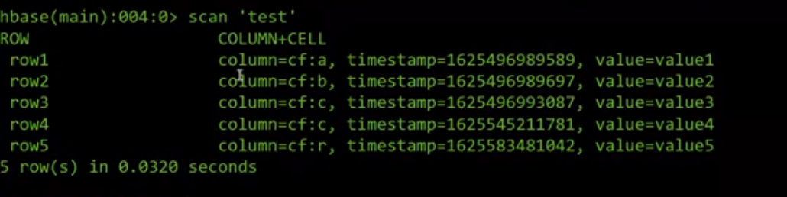

Now, try with duplicate value at row 5 say value t

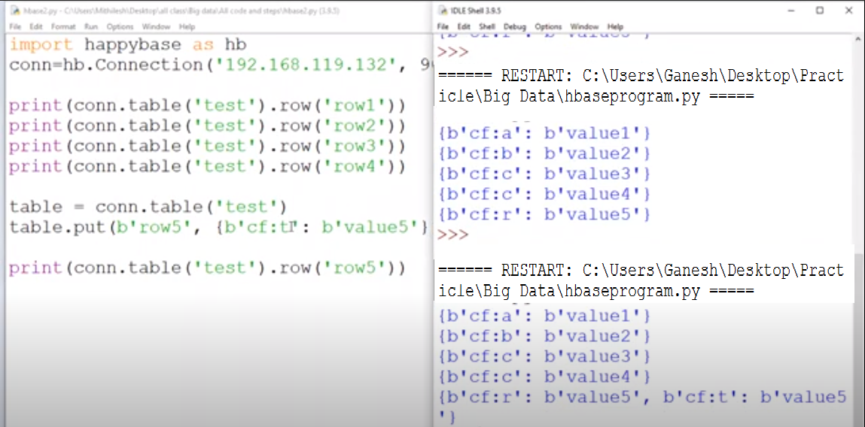Run a scan command on shell to display the values

When there is unique value, it will create a record. If duplicate value it will not create a record

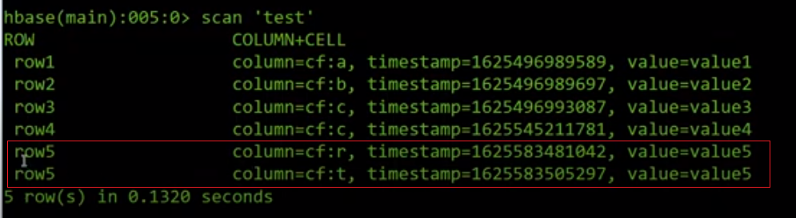

**Practical 7**

|  |
| --- |
| Implement Decision tree classification techniques**Decision Trees (DTs)** are a non-parametric supervised learning method used for [classification](https://scikit-learn.org/stable/modules/tree.html#tree-classification) and [regression](https://scikit-learn.org/stable/modules/tree.html#tree-regression). The goal is to create a model that predicts the value of a target variable by learning simple decision rules inferred from the data features. A tree can be seen as a piecewise constant approximation.Using the Iris dataset, we can construct a tree as follows:    Once trained, we can plot the tree with the [**plot_tree**](https://scikit-learn.org/stable/modules/generated/sklearn.tree.plot_tree.html#sklearn.tree.plot_tree) function: |

**Practical 8**

|  |
| --- |
| Implement SVM classification techniques |

**Support Vector Machines**

Generally, Support Vector Machines is considered to be a classification approach, it but can be employed in both types of classification and regression problems. It can easily handle multiple continuous and categorical variables. SVM constructs a hyperplane in multidimensional space to separate different classes. SVM generates optimal hyperplane in an iterative manner, which is used to minimize an error. The core idea of SVM is to find a maximum marginal hyperplane (MMH) that best divides the dataset into classes.**Loading data:**

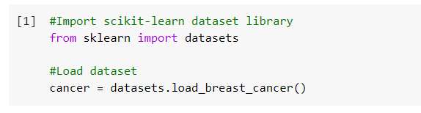

**Exploring data:**

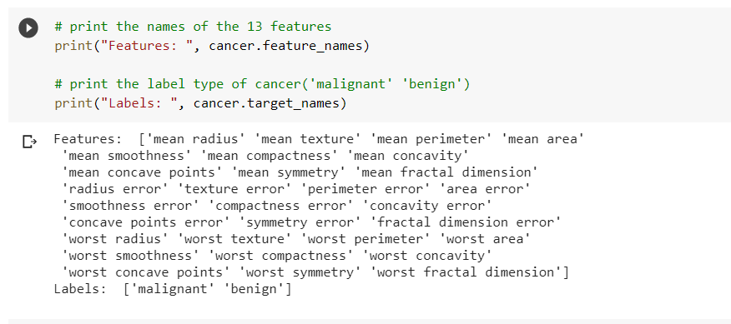

Check the shape of the dataset using shape.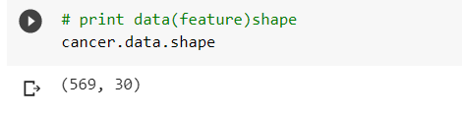

Check top 5 records of the feature set.

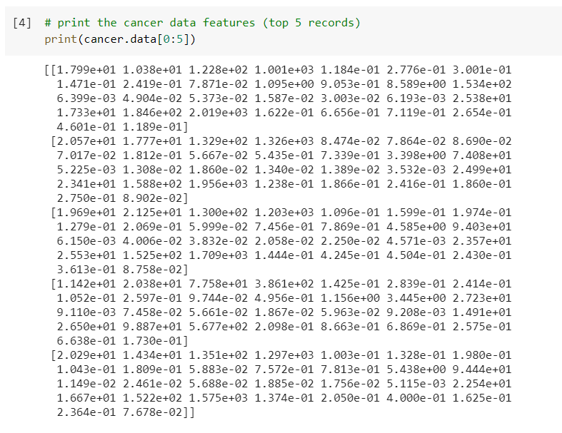

**Target set:**

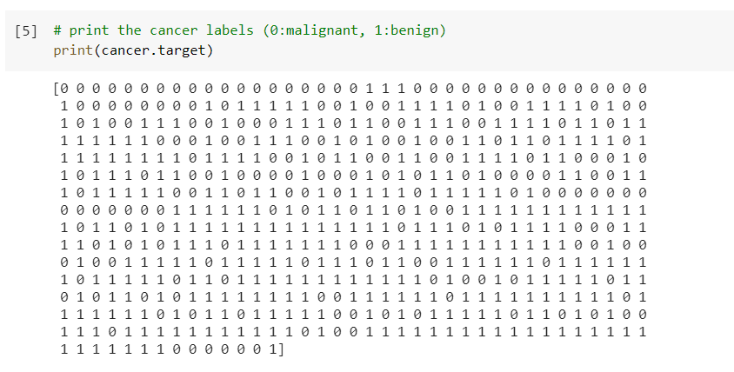

**Splitting Data:**

To understand model performance, dividing the dataset into a training set and a test set is a good strategy.

Split the dataset by using the function train_test_split(). you need to pass 3 parameters features, target, and test_set size. Additionally, you can use random_state to select records randomly.

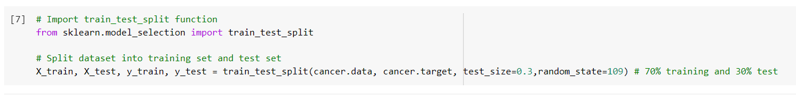

**Generate Model:**

Let's build support vector machine model. First, import the SVM module and create support vector classifier object by passing argument kernel as the linear kernel in SVC() function.

Then, fit your model on train set using fit() and perform prediction on the test set using predict().

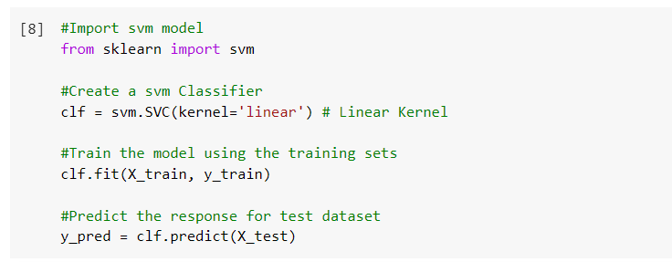**Evaluating the Model:**

Let's estimate how accurately the classifier or model can predict the breast cancer of patients. Accuracy can be computed by comparing actual test set values and predicted values.

